

AGENCY FOR THE PROTECTION OF THE RIGHT TO FREE ACCESS TO PUBLIC INFORMATION

REPORT ON THE CONDUCTED VERIFICATION OF THE PUBLISHED DOCUMENTS AND INFORMATION WHICH THE HOLDERS OF THE STATE INSTITUTIONS IN THE REPUBLIC OF NORTH MACEDONIA ARE OBLIGED TO PUBLISH ON THEIR WEBSITES

Skopje, December 2025

CONTENTS:

INTRODUCTION: 3

WHAT IS PROACTIVE TRANSPARENCY? 4

SUBJECT OF THE MONITORING: 5

OBJECTIVE OF THE MONITORING: 6

MONITORING FREQUENCY: 6

REFERENCE FRAMEWORK: 7

First Group: ACCESS TO INFORMATION 14

Second Group: ORGANIZATIONAL STRUCTURE 17

Third Group: OPERATIONAL 18

Fourth Group: BUDGET, FINANCIAL OPERATIONS AND PUBLIC PROCUREMENT 19

CONCLUSIONS AND RECOMMENDATIONS: 25

ANNEXES: 27

Table of Monitoring Results for 2025 27

Comparative Table of Monitoring Results of State Institutions for 2024–2025 31

Table of Holders Without Websites 36

List of Categories of Information for Proactive Transparency 37

Authors: Oliver Serafimovski

Melanie Ibraimi

Graphic Design: Dean Jadrovski

INTRODUCTION:
Information of public importance is available to citizens in two ways – through the proactive actions of the institutions themselves and through reactive means, that is, by submitting a request for information to certain public institutions. Proactive transparency implies the timely publication of information of public interest by institutions on their own initiative, before it is requested by requesters, whether orally, in writing, or electronically, through clear and transparent websites that contain all information relevant to citizens.
All obligations of institutions to make their work transparent also apply to state institutions. Central government institutions must protect the freedoms and rights of citizens, the rights and interests of legal entities established by law, and ensure constitutionality and legality. For this reason, it is important that citizens are informed in a timely and clear manner about all information of public relevance. The Government, Parliament, ministries, subordinate bodies, as well as independent institutions, are obliged to provide citizens with access to this information.
Institutional transparency is a principle that encompasses a wide range of policies, mechanisms, and institutional practices aimed at increasing transparency, accountability, and active public participation in governance processes. As a value and a strategic approach, transparency creates conditions for more informed and inclusive decision-making, reduces the potential for corrupt practices through publicly accessible and verifiable information, and contributes to more efficient and higher-quality public services. The application of transparency principles – such as proactively publishing information and involving citizens in policy-making processes – fosters a more constructive relationship between institutions and citizens and strengthens democratic processes in society.
The overall goal of this monitoring is to assess the level of proactive transparency of state institutions. This report presents the findings of the monitoring, which examined the extent to which the President of North Macedonia, the Parliament, the Government, ministries, subordinate bodies, agencies, bureaus, institutes, directorates, the Archives of North Macedonia, commissions, institutes, administrations, funds, centers, the State Attorney’s Office, the Inspectorate Council, the National Bank of North Macedonia, the Audit Body for Pre-Accession Assistance, the National Road Safety Council, the Council for Audit Promotion and Oversight, and the Central Registry publish information relevant to citizens, including annual reports on their work, whether they provide accurate, precise, and complete data to information requesters, whether an official responsible for mediating access to public information is designated, as well as numerous other issues used to evaluate compliance with standards for proactive transparency.
Such proactive publication of information contributes to strengthening the rule of law and enables the public to become familiar with regulations, decisions, and other actions that affect their interests, thereby reinforcing citizens’ trust in institutions.

WHAT IS PROACTIVE TRANSPARENCY?
When holders of public information are open to the public, citizens can easily learn what and how state authorities and other institutions operate. This enables them to participate equally in public life and continuously monitor the actions of the authorities.

Proactive publication of public information is a legal obligation of all holders, requiring them to publish, on their own initiative and continuously on their websites, information about their work and operations, decision-making, finances, and the services they provide to citizens.

The purpose of fulfilling the obligation for proactive publication of information is reflected in enabling citizens/requesters to exercise their constitutionally guaranteed right of access to information, by receiving services from information holders in a simple and fast manner. At the same time, information holders gain necessary legitimacy as they demonstrate responsibility in their operations, thereby restoring citizens’ trust in institutions.

Through proactive publication of public information, holders clearly establish their legal obligation not only to respond to submitted requests under the Law on Free Access to Public Information but also to publish public information on their websites, including information that has not been requested. Proactive publication of public information is an integral part of the right of access to information, ensuring that key information is available in a timely manner. As the European Court of Human Rights notes, recognizing it as a fundamental human right, “information is perishable, and any delayed publication, even for a short period, can reduce its overall value and interest.”

Proactively published information by holders should be easily accessible and understandable, usable, relevant to citizens, and regularly updated. Information is a prerequisite for responsible governance and a foundation for democratic processes—information about the work of holders enables citizens to draw appropriate conclusions and participate in decision-making on matters of interest to them. Transparency and access to public information are inseparable tools in the fight against corruption.

A major advantage of proactively publishing public information, especially when done immediately, is that it makes it harder for information holders to deny the existence of information or manipulate it. This means that all citizens/requesters of public information save time, money, and effort. The principle of equality enables the realization of this right, fulfillment of obligations, and participation in political, social, and economic processes, all aimed at strengthening trust in institutions. Low proactivity in publishing information prevents the public from monitoring and controlling the work of information holders.

SUBJECT OF THE MONITORING:
The monitoring is focused on checking the categories of information that should be regularly and timely published on the websites of holders of public information in accordance with the provisions of Articles 9 and 10 of the Law on Free Access to Public Information (LFAPI).
OBJECTIVE OF THE MONITORING:
The objective of the monitoring is to detect the status of the implementation of the obligation of holders of public information to proactively publish the 22 categories of information on their websites. This helps in the realization of the mandate of the Agency for the Protection of the Right to Free Access to Public Information to enforce the provisions of the LFAPI and to strengthen the capacities of holders of public information regarding greater transparency and openness. Additionally, the monitoring will contribute to better identification of the training needs of the officials within the holders of information.

FREQUENCY OF MONITORING:

The frequency of monitoring can be once a year, on an annual basis, or over a longer period. In order to ensure comparability of results and to use them for identifying problems, training needs, and strategy development, it is worthwhile for monitoring to be conducted frequently enough.

For a priority group, such as state administration bodies, it is recommended to maintain an annual monitoring frequency.

Monitoring of municipalities can be conducted once a year or every two years.

Monitoring of public enterprises can be conducted on an annual or biennial basis.

Monitoring of other categories, such as courts, schools, and universities, hospitals, and other medical bodies, can only be conducted through a special assignment with allocated financial resources and/or in cooperation with the civil sector.

Monitoring can also be carried out as thematic tracking of the websites of the holders (e.g., publication of public procurement procedures, budget, employment, environment, and other content), again with allocated financial resources and/or in cooperation with the civil sector.

FRAME OF REFERENCE:

The reference framework for monitoring is the questionnaire developed specifically for this purpose based on the categories listed in Article 10 of the LFAPI. The questionnaire distinguishes relevant questions for the groups of state authorities and for the group of municipalities. The questionnaire will differ in several segments, namely in the area of ​​concession awarding and public-private partnership, since a large part of the holders do not have such legal obligations. These questions will remain as part of the questionnaire intended for municipalities.

MONITORING RESULTS:

The Agency, in accordance with its competencies and in accordance with the Action Plan (2023-2026) for the implementation of the Public Administration Reform Strategy 2023-2030, has included in the specific objective Measure 3.4.1. Improving the tools for the availability of public information. The measurability of this measure is provided for by the Indicator: "Percentage of state institutions that regularly publish and update documents on their websites in accordance with the LFAPI". For this purpose, in 2025, the Agency conducted monitoring of the websites of the holders of state institutions.
The Agency monitored 99 holders, i.e. the websites of holders from state institutions, published on the List of Information Holders on the Agency's website. The monitoring was conducted in the period from October 20 to December 1, 2025. The Cooperation and Analysis Department was responsible for monitoring the websites for the full publication of documents and information that information holders are obliged to publish under Article 10 of the Law.
We should note that Monitoring does not analyze the content or the quality of the published information.
The monitoring was conducted in accordance with Article 10 of the Law on Free Access to Public Information (Official Gazette of the Republic of Macedonia No. 101/2019).
Out of a total of 133 state institutions recorded in the List as holders, the websites of 99 holders were monitored. Eleven holders were not included in the monitoring, as they do not have their own websites. Monitoring was not conducted on the websites of the National Security Agency, the Operational-Technical Agency, the Intelligence Agency, the Financial Police Directorate, the Financial Intelligence Directorate, as well as the Committee for the Investigation of Air Accidents and Serious Incidents due to their specific competencies and the determined level of classification of certain acts and documents. The website of one holder (the Crisis Management Center) could not be analyzed because while the website monitoring was ongoing, it was inactive, i.e. it could not be accessed, because the website was under construction. The Investment Fund was not monitored because the holder is no longer a legal entity and will be part of the Entrepreneurship Support Agency. While the monitoring was ongoing, the Fund's website did not exist at all. Also, the websites of the inspectorates were not part of the monitoring, for reasons that in accordance with the Law on Amendments and Supplements to the Law on Organization and Work of the Bodies of State Administration ("Official Gazette of the Republic of North Macedonia" No. 121/2024) they continue to operate as bodies within the Ministries, without the status of legal entities. The inspectorates, in accordance with the amendments and supplements to the ZORODU, are no longer holders of information in accordance with the Law on LFAPI.
The monitoring was conducted in accordance with the methodology implemented in cooperation with external experts, engaged by the IPA II Project "Transparency and Accountability of Public Administration", whose beneficiary is the Agency. The prepared questionnaire contains a total of 31 questions arising from Article 10 of the Law. Some of them contain one or more sub-questions, and the maximum number of possible points is 51. Holders of published data received 0, 0.5, and 1 point, depending on the number and up-to-dateness of the published documents. The questionnaire was distributed to the holders, who were asked to evaluate their own transparency, i.e. to indicate in the questionnaire with a link where the information is published on their websites.
Within the deadline set for submitting the questionnaires to the Agency, the holders submitted 59 answered questionnaires from a total of 99 monitored websites. The following are the holders who submitted answered questionnaires, i.e. performed a self-evaluation of their websites:

    - Directorate for Security of Classified Information
    - Ministry of Public Administration
    - Ministry of Social Policy, Demography and Youth
    - State Industrial Property Office
    - State Commission for the Prevention of Corruption - SCPC
    - Agency for Mandatory Petroleum Reserves-MAKORA
    - Agency for Supervision of Fully Funded Pension Insurance - MAPAS
    - The Republic of North Macedonia Health Insurance Fund
    - Public Revenue Office
    - State Commission for Public Procurement Complaints
    - Agency for the Promotion of Agricultural Development
    - Housing Regulatory Commission
    - Ministry of Defense
    - Food and Veterinary Agency Skopje
    - Parliament of the Republic of North Macedonia
    - Spatial Planning Agency
    - Ministry of Interior Affairs
    - Commission for Relations with Religious Communities and Religious Groups
    - Agency for Quality in Higher Education
    - Accreditation Institute of the Republic of North Macedonia
    - Ministry of Agriculture, Forestry and Water Management
    - Commission for Prevention and Protection against Discrimination
    - State Election Commission
    - Securities Commission of North Macedonia
    - Ministry of Finance
    - Public Procurement Bureau
    - Personal Data Protection Agency
    - Audio and audiovisual media services agency
    - Central Registry of the Republic of North Macedonia
    - State Statistical Office
    - Postal Agency
    - Civil Aviation Agency
    - Deposit Insurance Fund
    - National Bank of the Republic of North Macedonia
    - Railway Sector Regulatory Agency
    - President of the Republic of North Macedonia
    - Directorate for Protection and Rescue
    - Ministry of Education and Science
    - Ministry of Justice
    - Ministry of Inter-Community Relations
    - Institute for Standardization of the Republic of North Macedonia ISthe Republic of North Macedonia
    - Council for the Promotion and Supervision of the Audit of the the Republic of North Macedonia
    - State Audit Office
    - Radiation Safety Directorate
    - Regional Development Bureau
    - Audit Authority for the Audit of the Instrument for Pre-Accession Assistance
    - Agency for Medicines and Medical Devices
    - General Secretariat of the Government of the Republic of Macedonia
    - Ministry of Culture and Tourism
    - Civil Registry Office
    - State Attorney's Office of the Republic of Macedonia
    - Ministry of Digital Transformation
    - Hydrometeorological Department
    - Real Estate Cadastre Agency
    - Employment Agency of the Republic of North Macedonia
    - State Commission for Decision-Making in Administrative Procedures, Employment Procedures and Inspection Supervision in Second Instance
    - State Examination Center
    - Agency for the Implementation of the Language of the Republic of Macedonia
    - Agency for Financial Support in Agriculture and
rural development
The websites of the monitored holders are not unified, i.e. they differ both in design and in the structure of the content and the type of information they publish. While the monitoring was ongoing, the websites of the Government of the Republic of Macedonia and the ministries received a new design and were harmonized in terms of content. The updating of the websites is carried out in accordance with the activities of the institutions, whereby they fulfill the role of a primary source of information for citizens and the services they offer.
However, it should be emphasized that this year's monitoring showed that the majority of institutions do not have a banner/link titled "The List of information, Public information and Free access to information (thus providing easy and quick access to public information) and thus making it easier for requesters to access the information that is of interest to them. Still, there are holders who publish public information in sections such as "Information", "Public Relations", "Contact" or other categories, which can be confusing for users.
Additionally, the unsystematic placement of information creates confusion among citizens and significantly complicates access to the necessary data. This indicates the need for websites to be not only visually and structurally organized, but also functionally designed for easy navigation. The information that citizens need, which is part of the legal obligations for transparency of institutions, must be available quickly, intuitively and without unnecessary obstacles. Thus, a more efficient fulfillment of the right to access public information will be enabled and citizens' trust in the transparency of institutions will be strengthened.
Hence, we appeal to state institutions to make information easily accessible for citizens to use. "Informed citizens, satisfied citizens", that is the maxim for transparent state government.
Depending on the total number of points that the monitored holders received in relation to the published required documents and information in accordance with Article 10 of the Law, a gradation of the level of compliance with the legal obligation for their active transparency was made, as follows: holders with a very low level of transparency have between 0 and 13 points, with a low level between 13.5 and 26 points, holders with a medium level between 26.5 and 38 points, and with a high level of transparency from 38.5 to 51 points. In doing so, it was determined that 46 holders have a very good level of transparency in relation to the published information, 42 have a good level of transparency and 11 holders have an average level. This year, no monitored institution has been assessed with a very low level of compliance with regard to active transparency.
Of the 99 monitored state institutions, out of a total of 51 possible points according to the monitoring methodology, the average value of the proactive transparency of the holders is 37 points. This represents a high level of active transparency on the holders' websites or 72.54% of the published information of a public nature.
According to the results of the monitoring, the most transparent are the State Audit Office and the Health Insurance Fund with 51 points, followed by the State Commission for the Prevention of Corruption with 50.5, the Agency for Supervision of Fully Funded Pension Insurance MAPAS and the Ministry of Defense with 50 points. This year, the State Audit Office, which has very good transparency every reporting year, is ranked best in terms of its proactivity and the publication of necessary public information. The Health Insurance Fund shows the biggest jump in proactive publication of information, with an average of 26.5 points has maximum transparency this year on its website. This represents an improvement of 108% in proactive publication of public information, compared to previous monitoring. This result is due to the self-initiative of the responsible and official persons at the holder, and with the assistance of the Agency, to organize the website, as well as to publish the necessary information in accordance with Article 10 of the Law on FAPI. The Agency encourages other holders to contact the Agency, which will help them edit their websites and thus improve their proactive transparency. By publishing information on their websites, holders will reduce the number of requests submitted by applicants. This reporting year, there has been a decline in transparency at the Ministry of Agriculture, Forestry, and Water Management, which has recorded a decline of 12 places after two years. This year's monitoring showed that holders from agencies, commissions, and funds have improved their transparency, thus showing that by publishing information in a proactive manner, they can increase proactivity and accountability, primarily for citizens, and in this way, access to public information will be easily and conveniently available to applicants.
This year, the lowest proactive transparency was shown by: the Film Agency with 15 points, the Bureau of Metrology with 16 points, the Directorate for Technological Industrial Development Zones with 17 points, the Republic Council for Traffic Safety with 17.5 as well as the Directorate for Hydrometeorological Affairs with 17.5 points. The Bureau of Metrology, the Directorate for Technological Industrial Development Zones, and the Directorate for Hydrometeorological Affairs continuously show low proactive transparency. In the future, these institutions will need to publish on their websites the information they create and have at their disposal in accordance with Article 10 of the Law and thus raise the level of proactive transparency in their work.
Based on the monitored websites in accordance with the methodology and the Questionnaire, the following results and indicators for the proactive transparency of the holders were obtained:

First group: ACCESS TO INFORMATION

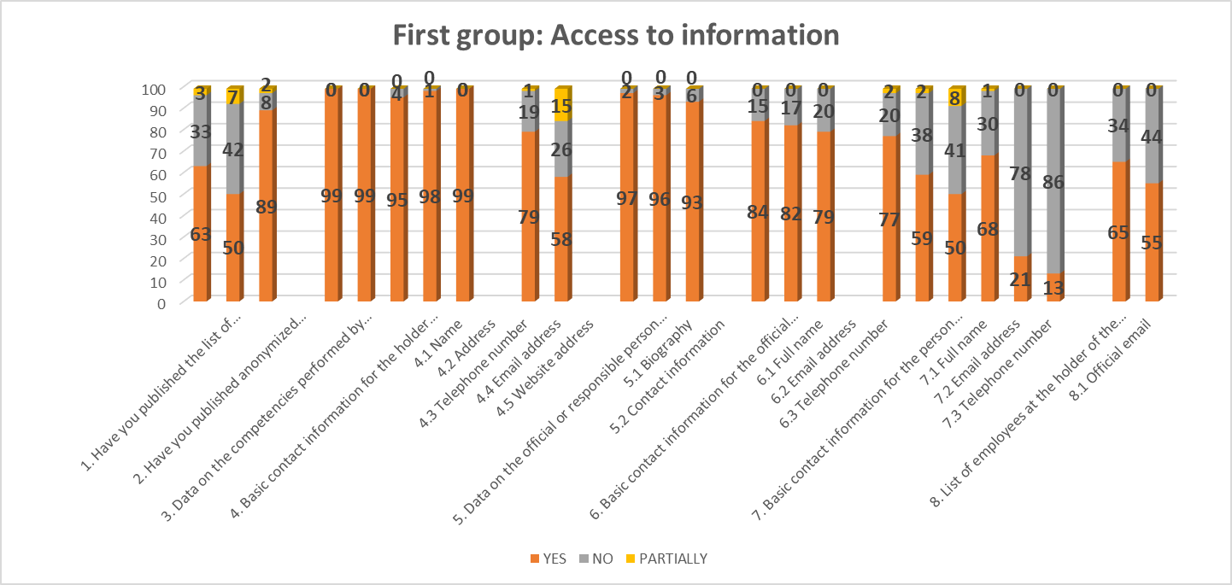
Out of a total of 99 monitored holders, 63 have published a link to the List of Information on the home page, and 33 do not have a banner/link. On their websites, holders, as an added value to access to public information, should publish anonymized requests/responses for free access for the last three years (2022, 2023, and 2024/5). This practice is practiced by 50 holders, while 42 holders do not publish them, thus preventing requesters from becoming familiar with the requests submitted to them on the basis of the Law on FAPI. Seven holders have partially moved the requests/responses submitted by requesters. 89 holders have published data on their jurisdiction, while only 8 do not move this information on their website. Two holders partially publish data on their jurisdiction. All holders have published the basic contact information for the holder of the information. Data about the official or the responsible person at the holder of the information: a biography on the websites have been published by 79 holders, and 19 have not published it. Partial/incomplete (with basic data) has been posted by one holder. Regarding the contact information of the official, 58 holders have published a contact phone number and official email address, while 26 institutions have not published this data on the website. 15 holders have partially posted the contact information, i.e. either the contact phones or information about the official email addresses are missing on the websites.
From the monitoring, we can conclude that in the free access to information link, 97 holders have published the name and surname of the official person for mediating with public information, while only two institutions have not published this obligation, leaving the requesters of these institutions without data and information to whom to submit their request and thus exercise their right to access information. 96 holders have published the official email addresses, and three of them have not published this contact form. 93 holders have published the official contact telephone number of the persons for mediating with information, while only 6 of them have not complied with this legal obligation.
Data on persons authorized for protected internal reporting, i.e. their name and surname, have been published by 84 holders, and 15 of them have not posted this information. 82 holders have published their official email addresses, and 17 have not fulfilled this obligation. 79 holders have published their contact phone number, while 20 holders have not posted this information. 77 institutions have published a list of persons employed by the holder of the information with a position, and 20 do not have data on their official email addresses, and only two institutions partially (i.e. the data refers only to management personnel). 59 of them have published their official contact phone numbers, while 38 institutions do not have this data on their websites, and two institutions partially (i.e. the data refers only to management personnel).
In the section on the clarification of the manner of submitting the request for access to information (method of submitting an oral, written request and electronically), 50 holders complied with this legal provision, while 41 holders did not include the clarification on access to public information. In part, 8 holders have only a short segment of this clarification, which is not useful for information seekers.
The form for requesting free access to public information has been uploaded by 68 holders, and 31 of them have not published it on their websites. Most of the monitored institutions still have the form in accordance with the 2006 Law and the amendments of 2010/15, which directs the requesters to request information through a law that is no longer in force.
In the 2025 monitoring, the questionnaire contained three new questions in accordance with the Excerpt from the Draft Minutes of the 101st Session of the Government of the Republic of North Macedonia, held on August 19, 2024, Item 12: Information on the level of implementation of the Transparency Strategy (2023-2026) by the Government, ministries and 20 government institutions.
Have you published the Procedure for Handling Requests for Free Access to Public Information? The monitoring showed that 21 holders have published them on the website, while 78 holders have not yet prepared and published this procedure.
While the Procedure for Proactive Transparency of Public Information has been published by 13 institutions, as many as 86 institutions have not yet published the procedure.
The annual report on access to public information for 2023 has been published on their websites by 65 holders, and 55 for 2024, while 34 have not published it for 2023 and 44 for 2024, in accordance with Article 36 of the LFAPI.

Second group: ORGANIZATIONAL ORGANISATION

From the second group of questions: ORGANIZATIONAL ORGANIZATION, the monitored 99 holders show very good transparency, and this can be seen from the table:
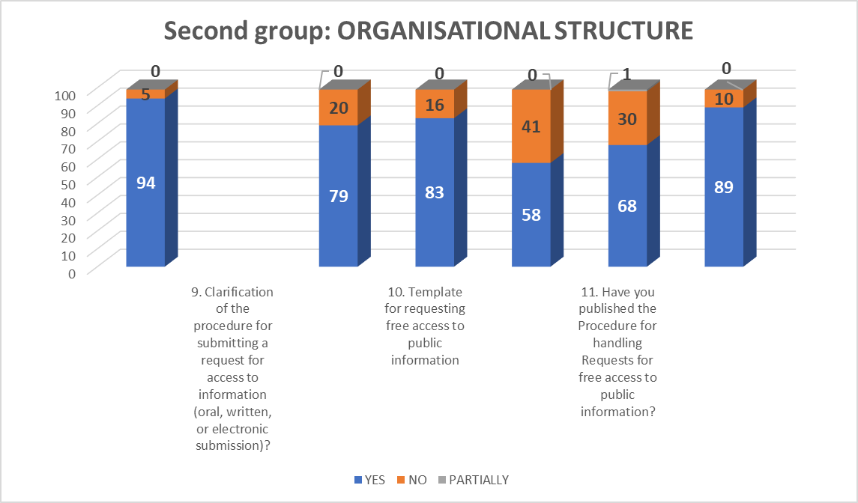
The laws relating to 94 holders have moved the information holder's jurisdiction, thus citizens, i.e. applicants, are familiar with the basic information on the basis on which holders from state institutions operate. Only five holders have not published the laws relating to their jurisdiction on their websites.
In the section in which the holders inform about the Regulations within their jurisdiction, in the form of a by-law, which refer to: the rulebook on internal organization, 79 holders have published it, and 20 have not uploaded this document. The rulebook on systematization of jobs, 83 entities have published it on their websites, and in 16 institutions, it cannot be found on their websites. The rulebook on protected internal reporting, of the monitored holders, has been published by 58 institutions, and 41 holders have not uploaded it.
In the area of ​​regulations, orders, and instructions, 68 holders publish these documents, and 30 holders of information have not published any information relating to this type of document.
The internal organization chart has been published on the websites of 89 holders of state institutions, and 10 holders have not published this information on their websites.

Third group: OPERATIONAL

In the third OPERATIONAL group of questions, which refers to information from the scope of their work and contains 7 questions, the monitored holders have very good proactive transparency.
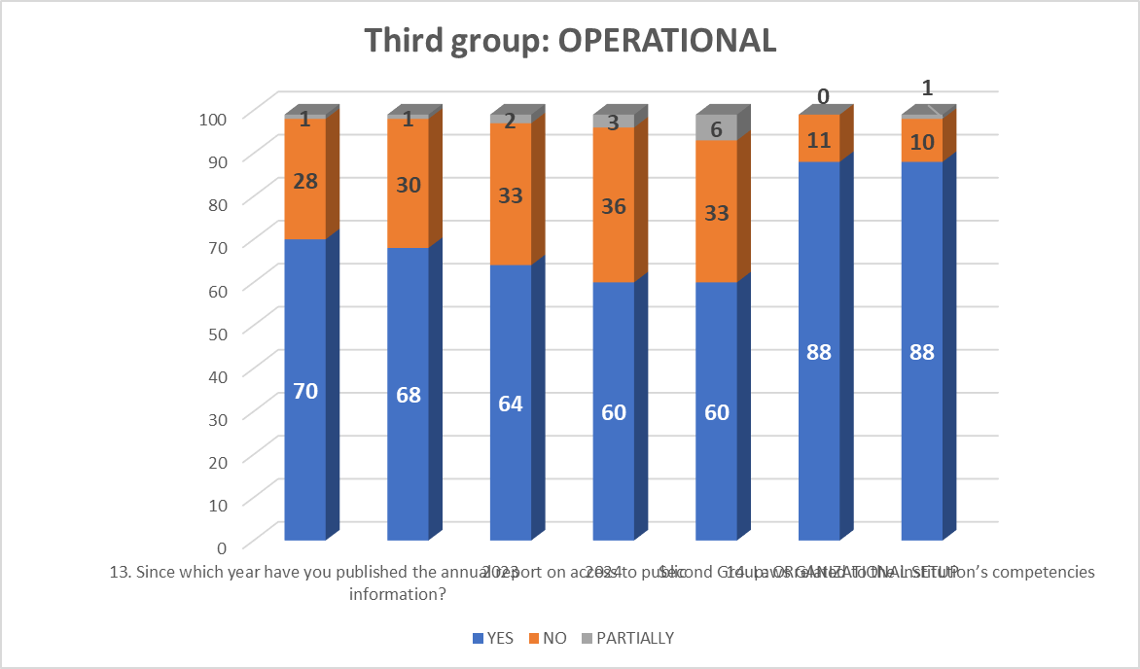
Strategic plans have been published by 70 holders, in contrast to 28 holders who have not posted this information on their websites. 68 holders have posted work strategies on their websites, and 30 of them do not have these documents or they are still published as documents on their websites, but they have long been completed and implemented. Two institutions have these documents in part.
64 holders have published annual plans and work programs, while 33 have not published this type of document. Two holders have partially published this information.
60 holders have draft documents (program proposals, programs, positions, opinions, studies) on their websites, and 36 have not published the documents. Of these, 3 holders have partial information regarding this category of information.
On the websites, in the section where holders publish reports on the work they submit to the supervisory authorities, 60 holders have published the reports, and 33 institutions have not posted this information that is of interest to information seekers. Some of the holders, or six holders, publish the reports as semi-annual or quarterly reports.
Information such as statistical data on work, as well as other information, the monitoring showed that 88 holders have posted this type of information, 11 institutions do not publish it, and three holders partially publish such data on their websites.
The monitoring of the information on the published acts and measures arising from the competence and work of the holder showed that the holders publish this type of information on their websites. Through links and access to them, citizens can access the information that is of interest to them, and this information is published on their websites by 88 holders. On the other hand, this information is not published in 10 institutions. One holder publishes this information on its websites partially.

Fourth group BUDGET, FINANCIAL OPERATIONS, AND PUBLIC PROCUREMENT

According to the monitoring, the holders also show good proactive transparency in the fourth group of questions: BUDGET, FINANCIAL OPERATIONS, AND PUBLIC PROCUREMENT. Holders should demonstrate improvements in this group of information because citizens' interest is focused mostly on the financial operations of institutions, and especially in the area of ​​published budgets, financial reports, audit reports, and the publication of information and documents related to public procurement.
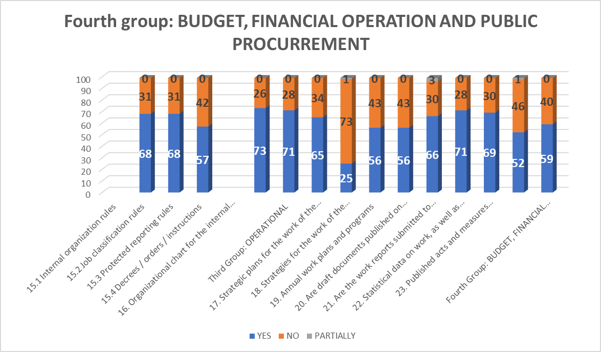
In the section related to budget transparency, the last three years (2023, 2024, and 2025) were monitored. Information about the budget for 2023, 68 holders have published the information and data, and 31 institutions have not posted this information on their websites. For 2024, 68 holders have published the budgets, while 31 holders do not have information regarding this legal obligation. The budget for 2025, 57 holders have published, and 42 institutions have not posted this information on their websites.
For information related to the publication of final accounts for the last three years (2022, 2023 and 2024), institutions show the same trend of proactive transparency as last year's monitoring. For 2022, 73 holders have published the information, while this data is not published on the pages of 26 holders. For 2023, 71 institutions have uploaded the required data, and 28 institutions have not uploaded this information. There is a decrease in the trend of publishing final accounts for 2024, where 65 holders have fulfilled the legal obligation, and 34 holders do not report information related to fiscal transparency at all. Only 25 holders have published quarterly financial reports for the current year, and 73 institutions do not publish these reports. In this segment of monitored holders, year after year, holders are the least likely to post this information on their websites, even though this is one of the pieces of information that shows how public money is spent.
We would like to point out to the monitored holders that they should not publish their budgets in PDF but in Excel format, so that they are clear and usable for citizens and those seeking public information. With this method of publication, the holders will follow the global trend of publishing this type of information, which is in an open format. Thus, the information becomes usable for the work of those seeking analyses and other types of information, which will make the finances more accessible to citizens. Also, each institution should publish its budget, and not as a complete Budget of the Republic of North Macedonia, because the same document will be unusable for those seeking information who are interested in obtaining the requested information from a particular institution.
By publishing this key financial document, citizens will be informed about the institutions' plans for how financial resources for their work will be spent and distributed. We would like to emphasize that publishing this information prevents potential corruption, and accountable publication reduces the risk, but also the suspicion of possible corrupt acts.
Regarding information on the audit performed, 56 institutions publish audit reports, while 43 holders do not publish the reports on their websites. The audit report is an important document for citizens/requesters, through which they can gain insight into the operations of the institutions and see the remarks made in these reports, but also see whether the institution has acted on the findings in them.
The results of the monitoring showed that in the area of ​​public procurement, the holders should be much more proactive, i.e. publish these documents. Thus, 66 institutions have published the annual public procurement plan out of a total of 99 institutions, while 30 holders do not have the plan posted on their website. By not publishing the plan, citizens cannot see what and how the institutions have foreseen that they need for their current operations. The failure to publish the annual plan raises suspicions of possible corrupt actions among the holders. By proactively publishing the annual public procurement plan, the institutions show their accountability in relation to public procurement. Partially, i.e. 3 holders, have published the annual plan as planned procurements on the website https://e-nabavki.gov.mk/.
Public procurement announcements for the current year 2025 have been published by 71 holders, while 28 institutions have not linked the information to their websites.
Notifications of concluded contracts were fulfilled by 69 holders, and 30 institutions did not publish the notification. The publication of information in the public procurement section is one of the basic parameters in the anti-corruption work of institutions, but also for increasing the trust of citizens in their work.
A new question was added to the questionnaire submitted to the monitored holders, which refers to the published Public Procurement Procedure, and the following results were obtained: 52 holders have published the Procedure, while 46 institutions have not complied with this obligation. Only one holder has partially prepared this procedure, which is actually kept as a guideline.
According to the Excerpt from the Draft Minutes of the 101st Session of the Government of the Republic of North Macedonia, held on August 19, 2024, Item 12: Information on the level of implementation of the Transparency Strategy (2023-2026) by the Government, ministries and 20 government institutions, the monitoring for items 2, 6 and 7 shows the following results:
Point 2. Ministries and other state administration bodies are obliged, and institutions that do not have the status of state administration bodies are instructed, within 45 days, to publish on their websites all information resulting from already answered requests for access to public information, anonymized, starting from 24.06.2024.
Following this commitment, 20 institutions acted, 15 did not act, and three institutions partially complied with the commitment.
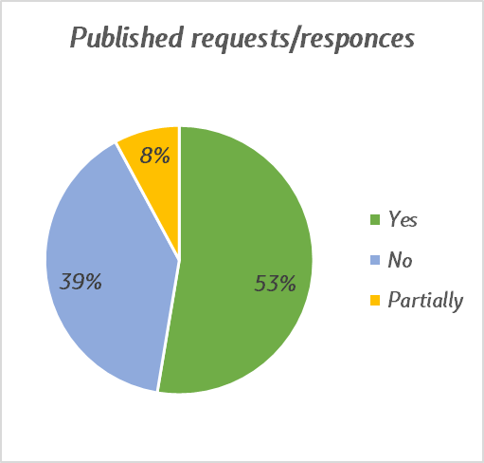
Point 6. Ministries and other state administration bodies are obliged, and institutions that do not have the status of state administration bodies are instructed, within 60 days, to adopt internal procedures for acting upon requests for access to public information and internal procedures for active publication of data with the assistance of the Agency for the Protection of the Right to Free Access to Public Information to facilitate the process of responding to requests for free access.
Following the obligation, only 8 institutions acted, while 30 did not comply with the obligation regarding internal procedures for acting upon requests for access to public information.
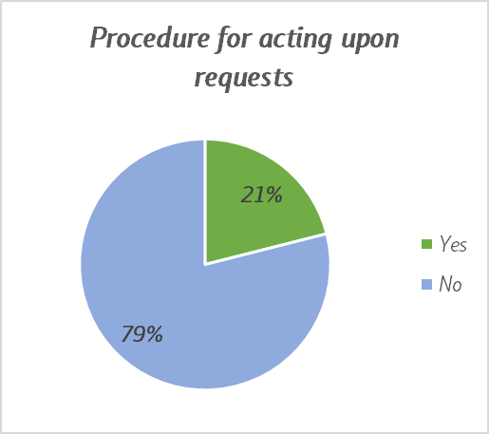
While, only 3 institutions took action to publish internal procedures for active data publication, while 35 did not comply with the obligation.
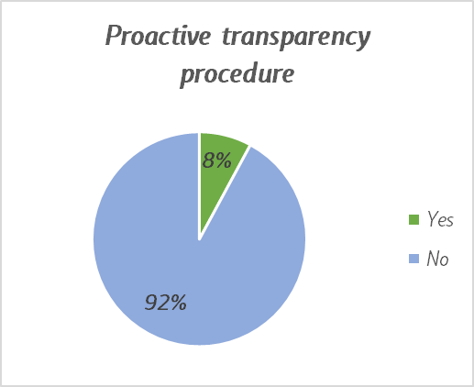
Point 7. Ministries and other state administration bodies are obliged, and institutions that do not have the status of state administration bodies are instructed to publish the internal public procurement procedures on their websites within 30 days.
The obligation to publish internal public procurement procedures was complied with by 21 institutions, while 17 holders did not publish the required procedure on their websites.
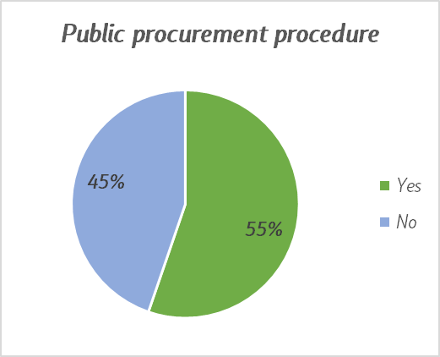

CONCLUSIONS AND RECOMMENDATIONS:

The level of transparency and accountability in the work of state administration bodies has been assessed as a high level of transparency this year. The improvement is among the holders of funds, agencies, and administrations, and the monitoring showed that the majority of institutions show "very good" transparency, but in order to maintain and improve this level, consistent compliance with transparency and accountability standards is necessary. Only through such an approach will institutions become more accessible to citizens, as end users of public information.
For institutions with an "average" level of transparency, which are mostly repeated every year, significantly greater investment is needed in improving their proactivity towards citizens. One of the recommendations is to establish a unified and visible banner on their websites with the title"PUBLIC INFORMATION", where all relevant information will be published. This will not only facilitate access for citizens but will also reduce the number of requests submitted for free access to information. The Agency also calls on them to jointly edit their websites in accordance with Article 10 of the LFAPI to improve their transparency and bring their work closer to citizens in a quick and efficient manner.
Current practice shows that sub-links such as "Free Access", "Transparency" or "Public Information" are often placed in obscure and difficult-to-access parts of the websites. Therefore, institutions should regularly update and structure this information, and publish it in accordance withArticle 10 of the Law on Free Access to Public Information and their responsibilities on the home pages.
The establishment of a unified banner with a clear structure and regularly updated data will ensure greater accessibility of information. This will allow citizens quick and easy access to relevant data, which is crucial for strengthening their trust in institutions and for their active participation in decision-making processes. In addition, this will enable transparent monitoring of the activities and services of institutions.
The Agency for the Protection of the Right to Free Access to Public Information will continue with continuous training for officials in institutions, placing special emphasis on active transparency and consistent application of Article 10 of the Law. These trainings will help officials not only understand legal obligations, but also improve the availability of information of public interest.
Active transparency plays a key role in:
- Improving citizens' understanding of the functioning of institutions.
- Enabling citizens to exercise their rights and obligations.
- Encouraging participation in making decisions that affect their lives.
- Easy access to public services offered by institutions.
Only by continuously improving transparency and accountability will institutions strengthen trust among citizens and increase the quality of services. Through visibility, proactivity and constant updating of information, state administration bodies can become an example of effective and accountable governance.

ATTACHMENTS:

Table with monitoring results for 2025

R. No. | INSTITUTION | POINTS
1 | State Audit Office | 51 | VERY GOOD
1 | Rhe Republic of North Macedonia Health Insurance Fund | 51 | TRANSPARENCY
2 | State Commission for the Prevention of Corruption | 50,5
3 | Agency for Supervision of Fully Funded Pension Insurance MAPAS | 50
3 | Ministry of Defense | 50
4 | The Republic of North Macedonia Assembly | 49
5 | Audio and audiovisual media services agency | 48
5 | Food and Veterinary Agency | 48
6 | Securities Commission of the Republic of Macedonia | 47,5
7 | National Bank of the Republic of Macedonia | 47
8 | Customs Administration | 46,5
9 | Cadastre Agency | 46
9 | Ministry of Social Policy, Demography and Youth | 46
9 | Ministry of Finance | 46
10 | Public Procurement Bureau | 45,5
11 | Administration Agency | 45
11 | Civil Registry Office | 45
12 | Ministry of Justice | 44
12 | State Statistical Office | 44
12 | Energy and Water Services Regulatory Commission | 44
13 | Employment agency | 43,5
13 | Civil Aviation Agency | 43,5
13 | Ministry of Interior Affairs | 43,5
13 | Ministry of Agriculture, Forestry and Water Management | 43,5
14 | Railway Sector Regulatory Agency | 43
14 | Agency for Financial Support of Agriculture and Rural Development | 43
15 | Agency for Foreign Investment and Export Promotion of the Republic of Macedonia | 42
15 | State Industrial Property Office | 42
15 | Audit Authority for IPA Audit | 42
16 | Central registry | 41,5
17 | General Secretariat | 41
17 | Ministry of Local Self-Government | 41
17 | Institute for Standardization | 41
18 | Postal Agency | 40
18 | Regional Development Bureau | 40
18 | Accreditation Institute | 40
18 | Pension and Disability Insurance Fund | 40
18 | Inspection Council | 40
19 | Office of the Prime Minister of the Republic of Macedonia | 39,5
20 | Ministry of Public Administration | 39
20 | State Commission for Public Procurement Complaints | 39
20 | Ombudsman | 39
21 | Legislation Secretariat | 38,5
21 | Ministry of Energy, Mining, and Mineral Resources | 38,5
21 | Directorate for Security of Classified Information | 38,5
21 | Public Revenue Office | 38,5
22 | Ministry of Health | 38 | GOOD
22 | Ministry of Education and Science | 38 | TRANSPARENCY
22 | State Archives | 38
22 | Council for the Promotion and Oversight of Auditing | 38
23 | Ministry of Culture and Tourism | 37,5
24 | Ministry of Economy and Labor | 37
24 | Ministry of Environment and Physical Planning | 37
24 | State Commission for Prevention and Protection against Discrimination | 37
24 | State Attorney's Office of the Republic of Macedonia | 37
25 | State Election Commission | 36,5
26 | Appraisal Bureau | 36
26 | President of the Republic of North Macedonia | 36
27 | Personal Data Protection Agency | 35,5
27 | Ministry of Digital Transformation | 35,5
28 | State Examination Center | 35
29 | State Commission for Decision-Making in Administrative Procedures, Employment Procedures and Inspection Supervision in Second Instance | 34,5
30 | Cultural Heritage Administration | 34
30 | Bureau for Educational Development | 34
30 | Radiation Safety Directorate | 34
31 | Geological Survey | 33,5
32 | Agency for the realization of the rights of communities | 33
32 | Commission for Protection of Competition | 33
33 | Ministry of Foreign Affairs and Foreign Trade | 32,5
34 | Electronic Communications Agency | 32
34 | Agency for the Promotion of Agricultural Development - Bitola | 32
34 | Ministry of Transport | 32
35 | Emigration Agency | 31,5
35 | Agency for Quality of Health Institutions | 31,5
35 | Insurance Supervision Agency | 31,5
36 | The Republic of North Macedonia Representation Bureau before the European Court of Human Rights | 31
36 | Ministry of European Affairs | 31
36 | Deposit Insurance Fund | 31
37 | Spatial Planning Agency | 30
37 | Agency for Seized Property | 30
37 | National Agency for European Educational Programs and Mobility | 30
38 | Agency for Quality in Higher Education of the Republic of Macedonia | 29,5
38 | Vocational Education Center | 29,5
38 | Commission for Relations with Religious Communities and Religious Groups | 29,5
39 | Agency for Mandatory Oil Reserves MAKORA | 28,5
40 | Entrepreneurship Support Agency | 28
40 | Sanctions Enforcement Directorate | 28
41 | Housing Regulatory Commission | 27
42 | Agency for Medicines and Medical Devices | 26 | AVERAGE
42 | Directorate for Protection and Rescue | 26 | TRANSPARENCY
43 | Ministry of Sports | 25
44 | Commodity Reserves Agency | 23
44 | Ministry of Inter-Community Relations | 23
45 | Agency for the implementation of the language spoken by at least 20% of the citizens in the Republic of Macedonia | 21,5
46 | Hydrometeorological Department | 17,5
46 | Republic Road Traffic Safety Council | 17,5
47 | Directorate for Technological Industrial Development Zones | 17
48 | Bureau of Metrology | 16
49 | Film Agency | 15

Comparative table of results from monitoring of state institutions for 2024-2025

R. No. | INSTITUTION | 2025 | 2024 | Point of change | % change
1 | State Audit Office | 51 | 45 | 6,0 | 13,33
2 | The Republic of North Macedonia Health Insurance Fund | 51 | 24,5 | 26,5 | 108,16
3 | State Commission for the Prevention of Corruption | 50,5 | 49 | 1,5 | 3,06
4 | Agency for Supervision of Fully Funded Pension Insurance MAPAS | 50 | 45 | 5,0 | 11,11
5 | Ministry of Defense | 50 | 49 | 1,0 | 2,04
6 | The Republic of North Macedonia Assembly | 49 | 41 | 8,0 | 19,51
7 | Audio and audiovisual media services agency | 48 | 47 | 1,0 | 2,13
8 | Food and Veterinary Agency | 48 | 49 | -1,0 | -2,04
9 | Securities Commission of the Republic of Macedonia | 47,5 | 45 | 2,5 | 5,56
10 | National Bank of the Republic of Macedonia | 47 | 44 | 3,0 | 6,82
11 | Customs Administration | 46,5 | 37 | 9,5 | 25,68
12 | Cadastre Agency | 46 | 42,5 | 3,5 | 8,24
13 | Ministry of Social Policy, Demography and Youth | 46 | 48 | -2,0 | -4,17
14 | Ministry of Finance | 46 | 46 | 0,0 | 0,00
15 | Public Procurement Bureau | 45,5 | 46 | -0,5 | -1,09
16 | Administration Agency | 45 | 38,5 | 6,5 | 16,88
17 | Civil Registry Office | 45 | 27,5 | 17,5 | 63,64
18 | Ministry of Justice | 44 | 40 | 4,0 | 10,00
19 | State Statistical Office | 44 | 40,5 | 3,5 | 8,64
20 | Energy and Water Services Regulatory Commission | 44 | 37 | 7,0 | 18,92
21 | Employment agency | 43,5 | 38,5 | 5,0 | 12,99
22 | Civil Aviation Agency | 43,5 | 41 | 2,5 | 6,10
23 | Ministry of Interior | 43,5 | 45 | -1,5 | -3,33
24 | Ministry of Agriculture, Forestry and Water Management | 43,5 | 49 | -5,5 | -11,22
25 | Railway Sector Regulatory Agency | 43 | 38 | 5,0 | 13,16
26 | Agency for Financial Support of Agriculture and Rural Development | 43 | 44 | -1,0 | -2,27
27 | Agency for Foreign Investment and Export Promotion of the Republic of Macedonia | 42 | 40 | 2,0 | 5,00
28 | State Industrial Property Office | 42 | 37 | 5,0 | 13,51
29 | Audit Authority for IPA Audit | 42 | 45 | -3,0 | -6,67
30 | Central registry | 41,5 | 37,5 | 4,0 | 10,67
31 | General Secretariat | 41 | 39 | 2,0 | 5,13
32 | Ministry of Local Self-Government | 41 | 38 | 3,0 | 7,89
33 | Institute for Standardization | 41 | 33,5 | 7,5 | 22,39
34 | Postal Agency | 40 | 36 | 4,0 | 11,11
35 | Regional Development Bureau | 40 | 45,5 | -5,5 | -12,09
36 | Accreditation Institute | 40 | 35,5 | 4,5 | 12,68
37 | Pension and Disability Insurance Fund | 40 | 38 | 2,0 | 5,26
38 | Inspection Council | 40 | 45,5 | -5,5 | -12,09
39 | Office of the Prime Minister of the Republic of Macedonia | 39,5 | 43 | -3,5 | -8,14
40 | State Commission for Public Procurement Complaints | 39 | 42 | -3,0 | -7,14
41 | Ombudsman | 39 | 37,5 | 1,5 | 4,00
42 | Legislation Secretariat | 38,5 | 43 | -4,5 | -10,47
43 | Directorate for Security of Classified Information | 38,5 | 41 | -2,5 | -6,10
44 | Public Revenue Office | 38,5 | 40 | -1,5 | -3,75
45 | Ministry of Health | 38 | 39 | -1,0 | -2,56
46 | Ministry of Education and Science | 38 | 36 | 2,0 | 5,56
47 | State Archives | 38 | 36,5 | 1,5 | 4,11
48 | Council for the Promotion and Oversight of Auditing | 38 | 23,5 | 14,5 | 61,70
49 | Ministry of Culture and Tourism | 37,5 | 34 | 3,5 | 10,29
50 | Ministry of Economy and Labor | 37 | 33 | 4,0 | 12,12
51 | Ministry of Environment and Physical Planning | 37 | 36,5 | 0,5 | 1,37
52 | State Commission for Prevention and Protection against Discrimination | 37 | 35 | 2,0 | 5,71
53 | State Attorney's Office of the Republic of Macedonia | 37 | 34,5 | 2,5 | 7,25
54 | State Election Commission | 36,5 | 31,5 | 5,0 | 15,87
55 | Appraisal Bureau | 36 | 31 | 5,0 | 16,13
56 | President of the Republic of North Macedonia | 36 | 35,5 | 0,5 | 1,41
57 | Personal Data Protection Agency | 35,5 | 38,5 | -3,0 | -7,79
58 | State Examination Center | 35 | 41,5 | -6,5 | -15,66
59 | Cultural Heritage Protection Administration | 34 | 33,5 | 0,5 | 1,49
60 | Bureau for Educational Development | 34 | 33 | 1,0 | 3,03
61 | Radiation Safety Directorate | 34 | 30 | 4,0 | 13,33
62 | Geological Survey | 33,5 | 34,5 | -1,0 | -2,90
63 | Agency for the realization of the rights of communities | 33 | 25,5 | 7,5 | 29,41
64 | Commission for Protection of Competition | 33 | 30,5 | 2,5 | 8,20
65 | Ministry of Foreign Affairs and Foreign Trade | 32,5 | 31 | 1,5 | 4,84
66 | Electronic Communications Agency | 32 | 19,5 | 12,5 | 64,10
67 | Agency for the Promotion of Agricultural Development - Bitola | 32 | 40 | -8,0 | -20,00
68 | Ministry of Transport | 32 | 26 | 6,0 | 23,08
69 | Emigration Agency | 31,5 | 26 | 5,5 | 21,15
70 | Agency for Quality and Accreditation of Healthcare Institutions | 31,5 | 30 | 1,5 | 5,00
71 | Insurance Supervision Agency | 31,5 | 29 | 2,5 | 8,62
72 | The Republic of North Macedonia Representation Bureau before the European Court of Human Rights | 31 | 34 | -3,0 | -8,82
73 | Ministry of European Affairs | 31 | 30 | 1,0 | 3,33
74 | Deposit Insurance Fund | 31 | 36 | -5,0 | -13,89
75 | Spatial Planning Agency | 30 | 24 | 6,0 | 25,00
76 | Agency for the Management of Seized Property | 30 | 19 | 11,0 | 57,89
77 | National Agency for European Educational Programs and Mobility | 30 | 34 | -4,0 | -11,76
78 | Agency for Quality in Higher Education of the Republic of Macedonia | 29,5 | 24,5 | 5,0 | 20,41
79 | Vocational Education Center | 29,5 | 34 | -4,5 | -13,24
80 | Commission for Relations with Religious Communities and Religious Groups | 29,5 | 36 | -6,5 | -18,06
81 | Agency for Mandatory Oil Reserves MAKORA | 28,5 | 27 | 1,5 | 5,56
82 | Entrepreneurship Support Agency | 28 | 36 | -8,0 | -22,22
83 | Sanctions Enforcement Directorate | 28 | 25 | 3,0 | 12,00
84 | Housing Regulatory Commission | 27 | 17 | 10,0 | 58,82
85 | Agency for Medicines and Medical Devices | 26 | 25 | 1,0 | 4,00
86 | Directorate for Protection and Rescue | 26 | 28,5 | -2,5 | -8,77
87 | Commodity Reserves Agency | 23 | 23 | 0,0 | 0,00
88 | Ministry of Inter-Community Relations | 23 | 22 | 1,0 | 4,55
89 | Agency for the implementation of the language spoken by at least 20% of the citizens in the Republic of Macedonia | 21,5 | 24 | -2,5 | -10,42
90 | Hydrometeorological Department | 17,5 | 14 | 3,5 | 25,00
91 | Republic Road Traffic Safety Council | 17,5 | 18 | -0,5 | -2,78
92 | Directorate for Technological Industrial Development Zones | 17 | 15,5 | 1,5 | 9,68
93 | Bureau of Metrology | 16 | 17 | -1,0 | -5,88
94 | Film agency | 15 | 30 | -15,0 | -50,00

* In the comparison table, two institutions are not compared due to the fact that their websites were not active this year (Fund for Innovation and Technological Development and Center for Crisis Management), as well as the newly established ministries and institutions:
- Ministry of Digital Transformation
- Ministry of Public Administration
- Ministry of Energy, Mining, and Mineral Resources
- Ministry of Sports and
- The State Commission for Decision-making in Administrative Procedures, Employment Procedures, and Inspection Supervision in Second Instance
Directorate for Special Purpose Production
State Inspectorate for Forestry and Hunting
Seed and Planting Material Administration
Phytosanitary Administration
Pedagogical service
Port Authority-Ohrid
Property and Legal Affairs Office
State Foreign Exchange Inspectorate
Government Service for General and Common Affairs
Administration for the Affirmation and Promotion of the Culture of Members of Communities
Directorate for Development and Promotion of Education in the Languages ​​of Members of the Communities

Table of holders who do not have websites

List of categories of information for proactive transparency

First group ACCESS TO INFORMATION
1. Do you have a list of information published on your homepage?
2. Have you published anonymous requests/responses for free access to public information on your website?
3. Data on the competencies performed by the institution
4. Basic contact details for the information holder
4.1 name
4.2 addresses
4.3 phone number
4.4 email addresses
4.5 addresses on the Internet page
5. Data about the official or responsible person at the holder of the information
5.1 biography
5.2 contact details
6. Basic contact details for an official person for information mediation
6.1 name and surname
6.2 email addresses
6.3 telephone number
7. Basic contact details for a person authorized for protected internal reporting
7.1 name and surname
7.2 email addresses
7.3 telephone number
8. List of persons employed by the holder of the information with a position
8.1 official email
8.2 office phone
9. Clarification of the method of submitting the request for access to information (method of submitting an oral, written request or electronically)?
10. Form for requesting free access to public information posted
11. Have you published the Procedure for Handling Requests for Free Access to Public Information?
12. Have you published the Procedure for Proactive Transparency of Public Information?
13. Since which year have you started posting the annual report on access to public information?
2023
2024
Second group ORGANIZATIONAL ATTITUDE
14. Laws relating to the competence of the institution
15. Regulations adopted by the holder of the information within its competence in the form of a by-law
15.1 Internal Organization Rulebook
15.2 rulebook on job classification
15.3 protected reporting regulations
15.4 decrees / orders / instructions
16. Organization chart for the internal organization of the institution
Third group OPERATIONAL
17. Strategic plans for the work of information holders
18. Strategies for the work of information holders
19. Annual plans and work programs
20. Are draft documents (program proposals, programs, positions, opinions, studies) posted on the website?
21. Have the work reports you submit to the competent authorities been published?
22. Statistical data on the work, as well as other information
23. Published acts and measures arising from the competence and work of the information holder
Fourth group BUDGET, FINANCIAL OPERATIONS AND PUBLIC PROCUREMENT
24. Annual budget for the last three years
2023
2024
2025
25. Final account for the last three years
2022
2023
2024
26. Quarterly financial reports for the current year
27. Has your institution been audited?
27.1 Has the audit report been published?
28. Has the annual public procurement plan for the current year 2025 been published?
29. Are public procurement notices published for the current year 2025?
30. Is the notification of a concluded contract for the current year 2025 published?
31. Have you published the public procurement procedure?

