AGENCY FOR THE PROTECTION OF THE RIGHT TO FREE ACCESS TO PUBLIC INFORMATION

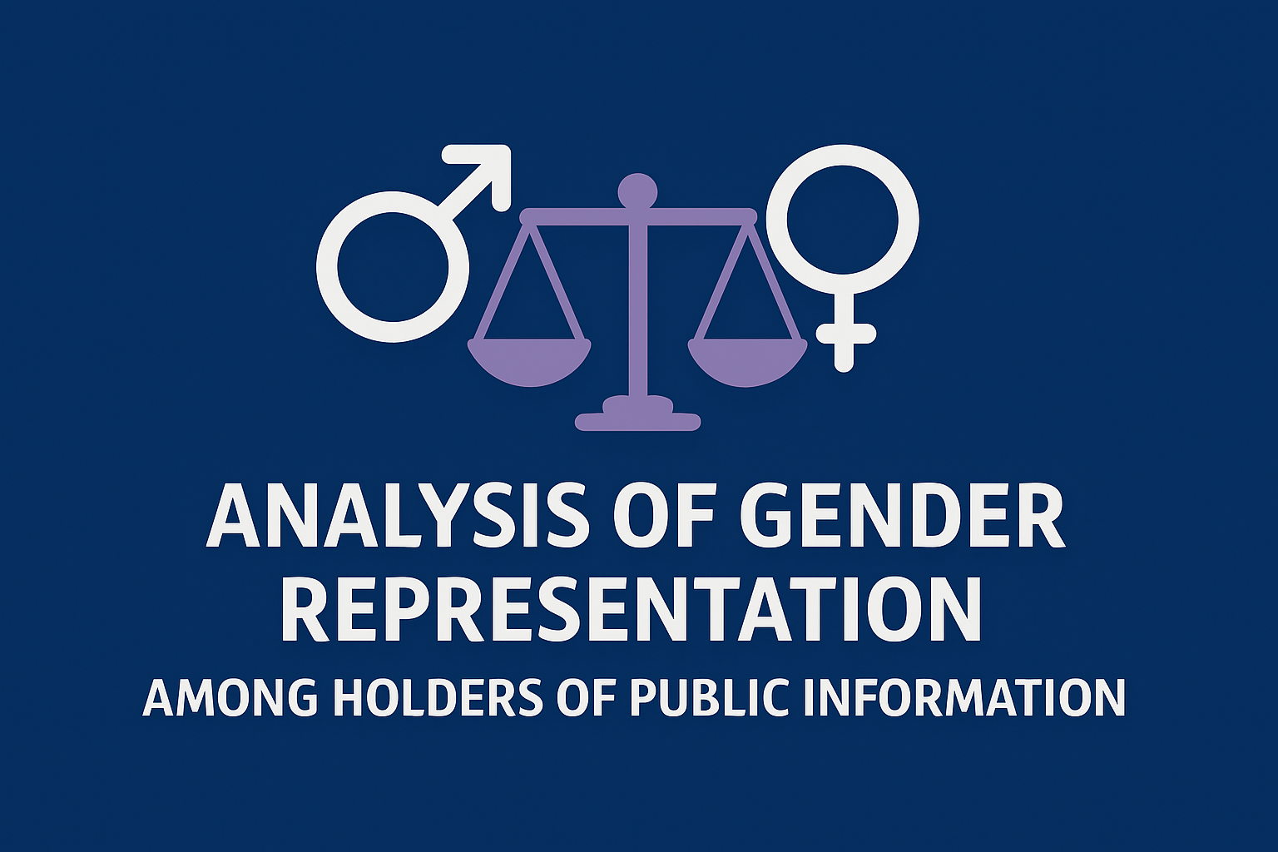

Skopje, November 2025

Free access to public information represents one of the fundamental human rights guaranteed by the Constitution of the Republic of North Macedonia. The realization of this basic human right is a key instrument for strengthening democracy, transparency, and accountability of public institutions. It enables citizens, the media, civil society organizations, and the wider public to monitor the work of public authorities, state administration bodies, local self-government units, and other holders of public authorizations, thereby directly contributing to reducing the risk of corruption, abuse of power, inefficient management, and poor decision-making.

In this process, the holders of information – the officials appointed within institutions to mediate access to information – play a central role, as they are the first point of contact between the institution and the public. Their responsibility is not only administrative but also substantive: they represent the public face of the institution in terms of transparency and ensure the practical implementation of the legal right to access information.

The analysis of gender representation among these officials is of particular importance. It is not merely a statistical indicator but also a reflection of broader social and institutional trends. The involvement of women and men in this field may reflect the distribution of gender roles within public administration, access to decision-making positions, and the degree to which the principles of equality are integrated into institutional practices. For example, the dominance of women in educational institutions and municipalities indicates a tendency for them to be represented in administrative and legal sectors, while the greater participation of men in political parties reflects the traditional distribution of roles within leadership structures.

Therefore, examining the gender aspect of information holders is not merely a matter of statistics, but also a tool for assessing institutional capacities and the inclusion of the gender perspective in public policies that can affect the effectiveness of the right to access information.

General gender representation of officials

The analysis of the List of Information Holders reveals a significant gender imbalance among the officials responsible for mediating the exercise of the right to access public information. Of a total of 1,776 officials, 1,175 are women (66%), while 601 are men (34%).

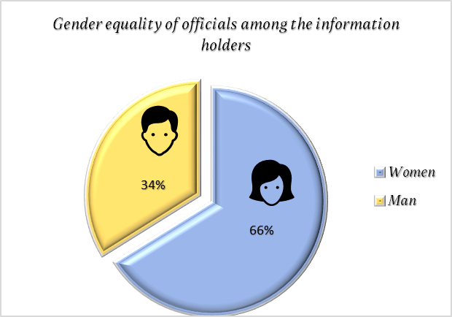

This highlights the dominance of women in this segment of public administration, with more than two-thirds of the officials being female.

According to the categories of holders, below we provide a graphical representation of the number of officials by gender distribution:

Category | Women | Men
Municipalities and Centers for Regional Planning Development | 84 | 41
Public Enterprises in the Republic of North Macedonia | 95 | 60
Public Institutions in the Republic of North Macedonia | 126 | 79
Legal and Natural Persons Exercising Public Authority and Activities  of Public Interest | 50 | 36
Educational Institutions | 527 | 218
State Administration Bodies | 129 | 48
Judicial Bodies | 48 | 30
Healthcare Institutions | 101 | 47
Political Parties | 15 | 42
Total | 1175 | 601

These figures indicate a significantly higher number of women serving as officials responsible for facilitating access to information, which can be interpreted as a positive indicator of their involvement and active role in transparency and accountability processes.

However, it is important to consider this statistic in a broader context: although women dominate among officials handling access to information, other sectors within information holders still show imbalance, with men predominating, especially in managerial positions. This suggests that gender balance has not yet been achieved and that the presence of women does not automatically mean full gender inclusivity across all administrative functions.

Furthermore, the analysis of gender representation can be used as an indicator of the degree of inclusivity and equal opportunities in the public sector, where the high representation of women as officials responsible for access to information can also serve as an example of good practice that can be promoted in other segments of social life. In this way, gender representation is not treated merely as a statistical category, but as an essential element of sustainable development and democratic governance.

Gender Representation by Categories of Information Holders
The analysis of gender distribution among officials responsible for access to information across different categories of information holders shows significant variations, revealing not only that women are more numerous in the public sector, but also highlighting the structural differences between various types of institutions.
1. Municipalities and Centers for Regional Planning Development
In local government units, women make up 67% of the officials, while men account for 33%. In absolute numbers, this corresponds to 84 women and 41 men. This dominance of women indicates their active role in the processes of facilitating access to information at the local level.
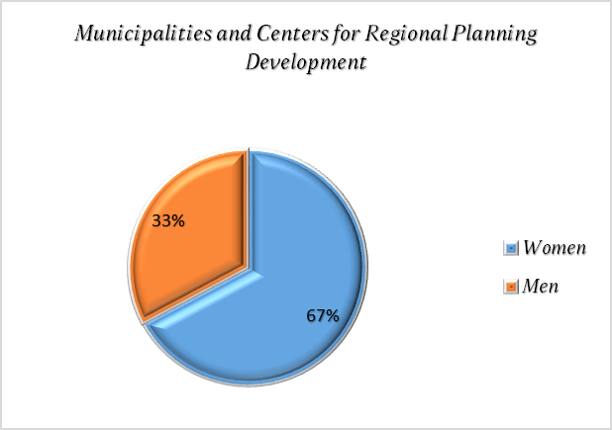
2. Public Enterprises
Women are represented with 61%, while men with 39% (95 women and 60 men). This data indicates a somewhat more balanced representation compared to local units, but women still hold a dominant role. This can be explained by structural characteristics of public enterprises, where positions related to facilitating access to information are often administrative and organizational roles in which women have traditionally been represented.
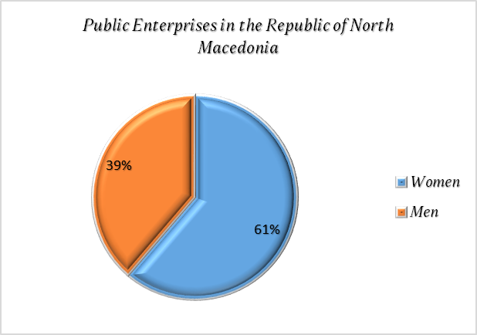
3. Public Institutions
Women make up 61%, and men 39% (126 women and 79 men). The statistics are similar to those of public enterprises and indicate a continuity in gender representation in these institutions.
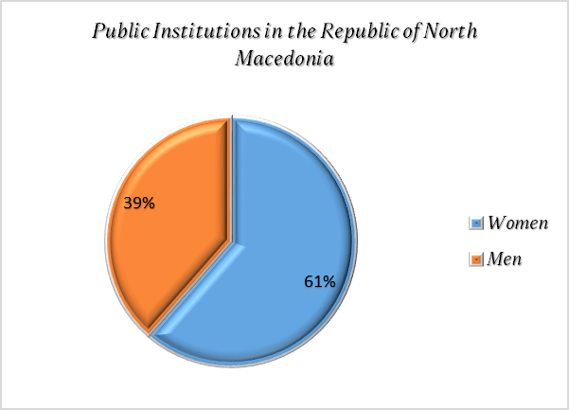
4. Other Legal and Natural Persons with Public Authority
Here, a more balanced distribution is observed: women are 58%, and men 42% (50 women and 36 men). The lower dominance of women indicates that in this segment, which includes various legal and natural persons with public authority, the representation of both genders is more balanced, which may be a result of the diversity of functions in these institutions.
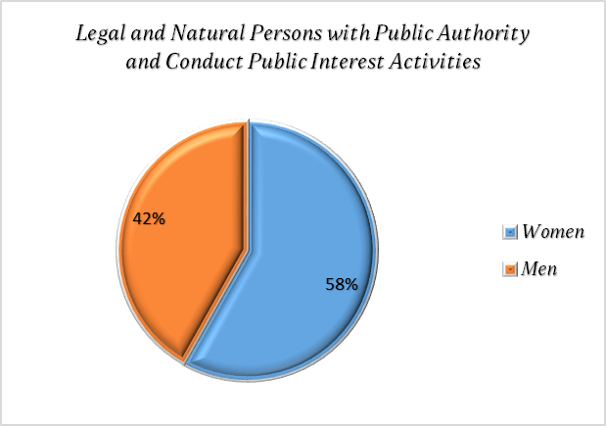
5. Educational Institutions
Women are absolutely dominant with 71% (527 women and 218 men), which is expected, considering that administration in educational institutions has traditionally been carried out by women. This highlights the gender structuring in the education sector, where women constitute a clear majority, especially in positions related to facilitating access to information.
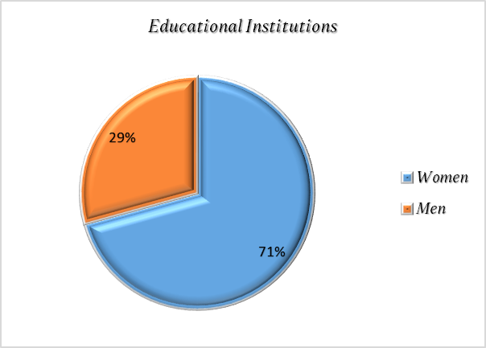
6. State Administration Bodies
Women are represented with 73%, while men are 27% (129 women and 48 men). This shows that at the central level, women are key actors in administrative processes related to transparency and access to information, which can also be interpreted as a positive signal for inclusiveness in public administration.
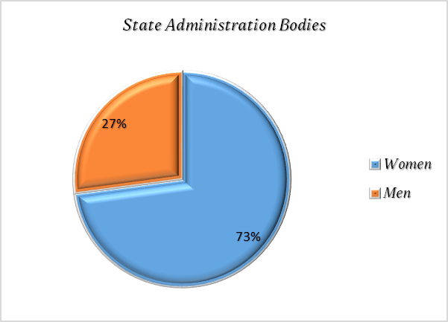
7. Judicial Bodies
Women make up 62%, and men 38% (48 women and 30 men). Although women are in the majority, these figures indicate a lower dominance compared to the education or state sector, which may reflect the traditionally higher representation of men in certain functions within the judiciary.
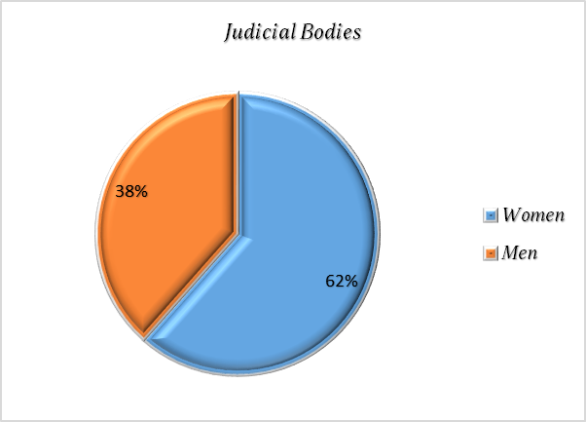
8. Healthcare Institutions
Women are represented with 68%, and men with 32% (101 women and 47 men). These statistics confirm the general picture that women dominate administrative and coordination functions in the healthcare sector, which is in line with global trends in health services.
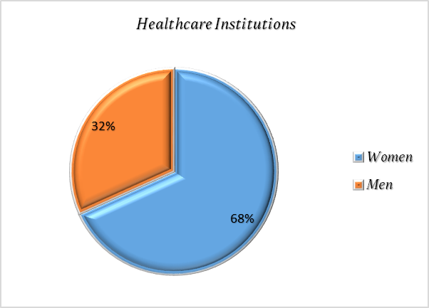
9. Political Parties
Only in this group is a dominance of men (74%) over women (26%) observed, with 42 men and 15 women. This indicates a structural gender imbalance in political organizations, where positions of officials facilitating access to information are most often held by men. This contrasts with all other categories and suggests that gender stereotypes and historical traditions are most pronounced in the political sector.
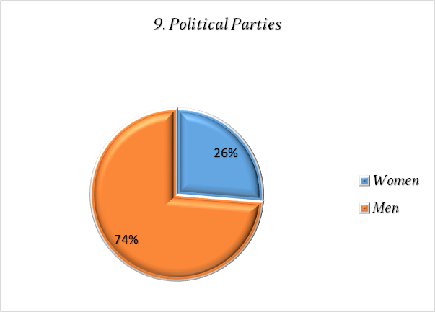
In general, an analysis of gender representation by categories shows that women are dominant in most public and administrative institutions, especially in education, healthcare, and state administration bodies. The exception is the political sector, where men are clearly dominant. These data indicate the potential for further gender analyses and policies for gender balance, particularly in institutions where men are underrepresented.
• The role of women in ensuring transparency and accountability
The dominant representation of women among most categories of information holders points to their key role in ensuring transparency and the effective realization of the right to access information. This can be seen as an indicator of gender inclusiveness in public administration, which aligns with modern equal opportunity policies.
• Gender inequality in the political sector
Despite the high percentage of women represented in the public sector, the political sector confirms the persistent gender inequality, where men dominate. This contrast indicates that gender stereotypes continue to influence the distribution of responsibilities and positions of power, which may affect the social status and visibility of women in political processes.
• Policies for promoting gender equality
The data point to an opportunity to develop policies that promote gender equality, particularly in sectors where men are underrepresented. Experiences from education, healthcare, and state administration can serve as examples of good practices in including women in public functions.
The structural analysis of gender representation among information holders reveals a stable trend of female dominance in the public sector, particularly in administrative and coordination functions. These data have significant social implications: they indicate the need for further advancement of gender equality, encouragement of equal opportunities, and promotion of women’s participation in all sectors of public life—especially in positions that influence the transparency and accountability of institutions.
With such measures, the gender representation of information holders can serve as an example of advancing equality in public administration, while also improving the effectiveness of the right to access information.
Gender equality among officials in trainings organized by the Agency
The analysis of data on the trainings organized by the Agency for officials responsible for mediating access to public information in 2024 and 2025 provides the following indicators:
• Gender equality in terms of trainings held in 2024
During 2024, the Agency conducted a total of 9 trainings, attended by 138 officials from 129 institutions. Of these, 120 were women (87%) and only 18 were men (13%). These figures show a clear dominance of women, which aligns with the general gender balance among access-to-information officers, where women form the majority. This trend indicates that women are not only more represented in these positions but also participate more actively in the training processes.
• Gender equality in terms of trainings held in 2025
In the first half of 2025, five trainings were organized, with a total of 50 participants from 33 institutions. Of these, 34 were women (68%) and 16 were men (32%). Compared to 2024, although women are still the majority, a more balanced gender distribution can be observed. The 32% participation rate of men indicates that their involvement in these professional development processes is increasing, which is a positive signal for improving gender balance.
• In 2024, women made up 87% of participants, and men only 13%.
• In the first half of 2025, women accounted for 68%, and men 32%.
This trend indicates a gradual reduction in the gender gap in training participation. While in 2024 there was a significant disproportion, in 2025 a tendency toward a more balanced distribution is observed.
These data confirm the importance of trainings as a mechanism not only for professional education and enhancement of administrative capacities but also for promoting gender equality.
• On the one hand, the high representation of women is an indicator of their active role in ensuring institutional transparency and accountability.
• On the other hand, the growing representation of men in 2025 highlights the need to use trainings as a tool for encouraging a more balanced gender distribution, in order to avoid excessive dominance of one gender.
The Agency, in its future trainings, will work toward balanced inclusion of both genders, thereby strengthening not only gender equality but also institutional efficiency in the implementation of the right to access information.

Recommendations for improving gender equality
• Developing integrated gender policies in the public sector
Institutions need to systematically integrate gender equality into human resource policies, in order to ensure balanced representation of women and men at all levels—from administrative to managerial positions.
• Increasing women’s participation in decision-making processes
Although women dominate as officials mediating access to public information, their participation in policy-making and decision-making remains limited. Measures are needed to encourage women to take on managerial and strategic roles, especially in sectors such as political parties.
• Balance in male-dominated sectors
In political parties and parts of the judiciary, it is necessary to create policies that enable a more even gender representation. This can be achieved through institutional mechanisms to prevent discrimination.
• Raising public awareness of the importance of gender balance
Public campaigns and educational programs should be developed to emphasize the importance of gender equality for transparency, accountability, and institutional trust.
• Exchange of good practices
Sectors with positive experiences—such as education, healthcare, and state administration—can serve as examples for developing models of inclusiveness that can be applied in sectors with more pronounced male dominance.

Conclusions
• Women as bearers of administrative accountability
The analysis confirms that women dominate as officials mediating access to information, especially in education, healthcare, and state administration bodies. This indicates that women are the main drivers of the practical implementation of the right to public information and that their presence serves as an indicator of the integration of gender equality within public administration.
• Structural differences between sectors
Although women play a dominant role in most of the public sector, political parties represent an exception, characterized by strong male dominance. This contrast reflects gender inequality in political life, where stereotypes and traditional roles remain deeply rooted.
• Gender representation as an indicator of institutional culture
Differences by category of information holders suggest that the representation of women and men is not only a matter of numbers but also a reflection of institutional culture, tradition, and organizational structure. This means that analyzing gender representation can serve as a tool for measuring the level of inclusiveness and equal opportunities within institutions.
• The gender aspect and transparency
The dominant role of women in mediation processes highlights their contribution to enhancing transparency and public trust in institutions. However, the fact that they are mostly represented in administrative roles rather than in decision-making positions shows that gender equality has not yet been fully achieved.
These recommendations and conclusions emphasize gender representation not merely as a matter of statistics but as a systemic indicator of democratic capacity, institutional culture, and the quality of transparency among information holders. Gender representation in institutions cannot be reduced to the numerical presence of women and men—it reflects broader social and political processes. Conversely, the imbalance or underrepresentation of women in certain sectors, such as political parties, signals the existence of structural barriers and entrenched cultural models that limit equality.
In this context, gender representation serves as a tool for measuring the maturity of democracy, as it directly reflects the level of institutional equality, transparency, and accountability toward citizens. With a systematic approach and sustained support, the public sector can become an example of effective implementation of gender equality principles, further contributing to transparency, accountability, and increased public trust.
Prepared by:
Melani Ibraimi
Oliver Serafimovski

