

**AGENCY FOR THE PROTECTION OF THE RIGHT OF FREE ACCESS TO PUBLIC INFORMATION**

**REPORT ON OBLIGATIONS RELATED TO THE AGENCY'S PROACTIVE TRANSPARENCY AND ACTIVITIES (JANUARY–JUNE 2025)**

**Skopje, August 2025**

Free access to public information is one of the basic prerequisites for the responsible and transparent operation of institutions. The active participation of citizens in political processes and the quality of their participation in shaping public policies and decision-making directly depend on how familiar and informed citizens are about these processes. That information is created and disposed of by the bodies of the state government and other bodies and organizations established by law, the bodies of the municipalities, the city of Skopje and the municipalities in the city of Skopje, institutions and public services, public enterprises, legal and natural persons exercising public powers established by law and activities of public interest and political parties in the area of ​​revenues and expenditures. Therefore, enabling access to this information is a necessary process that leads to the democratization of the policy-making and decision-making process, ultimately affecting the quality of life and overall well-being.

Familiarity with the relevant data is crucial for understanding the work of institutions. In this context, it is no longer possible to imagine quality participation in the processes of making political decisions without awareness and insight into the workings of public institutions. Hence, **Information is the power and oxygen of democracy!!!**

This report refers to the competences that the Agency has for proactive transparency, which includes data that demonstrates the transparency of holders through the monitoring of state administration bodies, local self-government units, and public enterprises under the jurisdiction of municipalities and the Government of the Republic of North Macedonia. The report also outlines the activities undertaken by the Agency from January to June 2025, in line with its competencies.

The agency encourages holders to proactively publish public information, ensuring that key information is available to citizens in a timely manner. The proactive publication of public information, as a legal obligation for holders, is derived from Article 10 of the Law on Public Information, which lists 22 categories of information that holders are required to publish on their websites. The published information helps citizens better understand the functioning of institutions, their rights and obligations, and how they can influence decisions that affect their daily lives and work. It also enables them to more easily access the services offered by the state. Transparency and access to public information are inseparable instruments in the fight against corruption.

The Agency presents the transparency and accountability of public sector institutions in this report, based on monitoring their web pages to assess the amount of mandatory information they publish in accordance with the Law on Free Access to Public Information.

Monitoring was carried out **on** **three** categories of holders, namely **242** institutions, in accordance with the Methodology for conducting monitoring for the proactive publication of public information. Questionnaires were submitted to the holders, adapted according to the competences of the monitored holders. The purpose of the questionnaires is to assess, through the self-evaluation of the holders, the extent to which they practice proactive transparency and fulfill their legal obligations in accordance with Article 10 of the Law on FAPI.

The categories of holders that were covered by the monitoring were: Municipalities and centers for the development of planning regions, Public enterprises and joint-stock companies under the jurisdiction of the municipalities and the Government of the Republic of North Macedonia, the Government, the ministries, and the bodies involved, according to the Transparency Strategy (2023-2026).

Proactive transparency implies the timely publication of public information by institutions that do so on their own initiative, before they are requested orally, in writing, or electronically, through clear, transparent, and easily accessible web pages that contain all the information of importance to citizens. Such proactive publication of information contributes to the strengthening of the law and enables the public to become familiar with regulations, decisions, policy-making, and other actions that are of interest to them and affect them in a timely manner.

The monitoring focuses on verifying the categories of information that should be regularly updated and published on the websites of public information holders, in accordance with Articles 9 and 10 of the Law on Free Access to Public Information (LFAPI). We should clarify that, with monitoring, the Agency does not analyze the content, i.e., the quality of the published information.

It should also be emphasized that the web pages of the holders are updated according to their activities and serve as the primary source of information for citizens, detailing the services they provide.

The Agency included in the Questionnaire the questions to which the holders had to move the link from the website on which they published the information, and it is focused on the most relevant (most important) three questions:

1. Have you published the mandatory information from Article 10 of the Law on Free Access to Public Information on the website by placing a banner in a visible place that leads to the public information?

2. Have you published anonymously on the website the requests for access to public information for 2023 and 2024, together with the answers that you have already provided to the requester, so that they can be reused by other natural and legal persons without resubmitting a request with the same content?

3. Have you published the information of a public nature systematized by area, in accordance with Article 10 paragraph 1 point 22 - "other information arising from the competence and work of the holder of the information" from the Law on free access to information of a public nature, as stated in the Guidelines for improving the transparency of public sector institutions?

Deadlines were set for each of the monitored holders, requiring them to submit answers to the self-evaluation questionnaires, that is, fill them in with the necessary data. They submitted completed questionnaires by the given deadlines, **with 123 holders, or 51% of the 242 holders to whom it was delivered. For these holders, it can be determined how much their transparency and accountability have improved** through the conducted self-evaluation.

* According to the categories of holders that the Agency maintains on its website [https://aspi.mk/листа-на-иматели-на-информации/](https://aspi.mk/%D0%BB%D0%B8%D1%81%D1%82%D0%B0-%D0%BD%D0%B0-%D0%B8%D0%BC%D0%B0%D1%82%D0%B5%D0%BB%D0%B8-%D0%BD%D0%B0-%D0%B8%D0%BD%D1%84%D0%BE%D1%80%D0%BC%D0%B0%D1%86%D0%B8%D0%B8/), from **242** holders who were covered by the monitoring answered questionnaires for self-evaluation **orderly and timely,** and also submitted:
* **Municipalities and Centers for the Development of Planning Regions: out of 90 holders, 38 holders submitted a questionnaire.**
* **Public enterprises under the jurisdiction of the municipalities and the Government of the Republic of North Macedonia: out of 43 holders, 28 holders submitted a questionnaire.**
* **The Government of the Republic of North Macedonia, the ministries and bodies in the composition, out of 109 holders, 57 holders submitted a questionnaire.**

According to the received answers to the Self-evaluation Questionnaire from the holders, we are attaching the table with the summarized data shown by the number of holders:

| **They have/questions** | **Number of monitored holders** | **Questionnaires answered** | **Have you published the mandatory information from Article 10 of the Law on Free Access to Public Information on your website, placing a banner in a visible location that links to the public information?** | **Have you published on your website the anonymized requests for access to public information for 2023 and 2024, along with the responses you have already provided to the applicants, to allow other natural and legal persons to reuse them without having to submit a new request with the same content?** | **Have you published the public information systematized by areas, in accordance with Article 10, paragraph 1, item 22 – other information arising from the competences and activities of the holder of the information under the Law on Free Access to Public Information, as specified in the guidelines for improving the transparency of public sector institutions?** |
| --- | --- | --- | --- | --- | --- |
| **Municipality And Centers for the development of planning regions** | **90** | **38** | **35** | **15** | **74** |
| **PE under the jurisdiction of the municipalities and the Government of the Republic of North Macedonia** | **43** | **28** | **24** | **14** | **39** |
| **The government of the Republic of North Macedonia, the ministries, and the bodies within** | **109** | **57** | **76** | **38** | **96** |
| **in total 246** | **242** | **123** | **135** | **67** | **209** |

**Notes:**

The total number of monitored holdersis 246, but among the state authorities, there are 4 holders who could not be monitored at the time of implementation of the monitoring, for reasons that the holdersdid not have a web page, or they were not functional in that aspect as wellthey were not part of the conducted monitoring.

Out of 90 holders from Municipalities and Centers for the Development of planning regions, 38 municipalities (42.22%) responded to the questionnaire via the attached link (**banner/link** **for Public** **information**).

Out of 43 holders in the group of public enterprises under the jurisdiction of the Municipalities and the Government of the Republic of North Macedonia, only 28 answered with an attached link, or 65.12%.

Out of 109 holders from the Government of the Republic of North Macedonia, including ministries and bodies, 57 holders, or 52.29%, submitted feedback with an attached link.

**APPENDIX:**

In addition to the analysis, a graphic presentation of the information from the obtained results, categorized by holders, has been created as an added value.

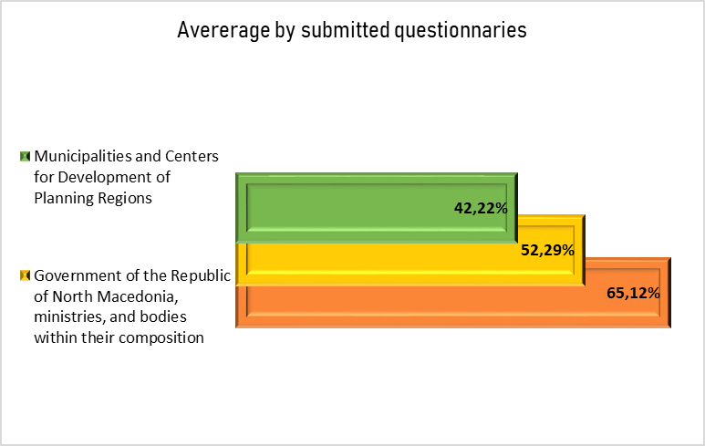

The cross-analysis of the self-evaluation results reveals significant differences in the level of transparency among the various categories of information holders. The highest self-evaluation is among public enterprises under the jurisdiction of municipalities and the Government of the Republic of North Macedonia, at 65.12%, while the lowest self-evaluation is among Local Self-Government Units, at 42.22%. The average of the conducted self-evaluation among all categories of holders is 53.21%, indicating that holders have improved their self-evaluation compared to last year's report; however, it remains within the medium range of transparency. The government of the Republic of North Macedonia, its ministries, and the bodies within it, unlike the last report, which showed a good level of transparent self-evaluation, this time recorded a significant decline.

This upward trend is encouraging, but it still moves within the medium level of transparency, which means that institutions still have considerable potential for developing and strengthening self-assessment processes. This decline is particularly significant because it affects institutions with the greatest responsibility and influence on the overall level of transparency, indicating the need for urgent measures to restore and improve the achieved standards.

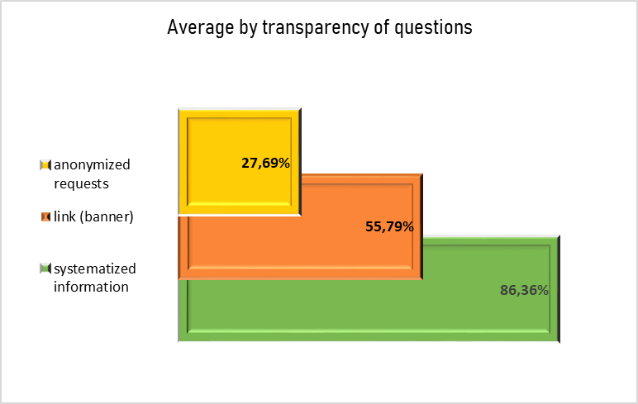

The data show that the holders of information continue to pay the most attention to the publication of information systematized by area, a practice applied by 86.36% of the institutions. This high percentage indicates that the institutions recognize the importance of structured and thematically organized publishing of information, thereby enabling easier availability and better visibility for users of their web pages.

In second place, according to representation, is the availability of published information through a clearly highlighted link or banner "Public information" on the websites of the institutions, which was provided by 55.79% of the holders. Although this is over half of the total number of institutions, the percentage still indicates that almost every second institution does not have visible and easy access to information, which reduces its practical effect for information requesters.

On the other hand, the weakest segment is the publication of anonymized requests and responses, which are crucial for building transparency and trust, as they enable citizens to gain insight into the type of information requested and the manner in which it is acted upon by the holders. This segment shows further deterioration: the representation dropped from 32% in last year's analysis to 27.69% this year. This decline suggests a possible lack of awareness or resources for the regular publication of such data, as well as a potential tendency for institutions to reduce transparency to meet formal legal obligations, without utilizing additional mechanisms for public accountability. The average level of transparency for this group of issues is 56.61%, positioning it within the "medium level of transparency" category.

This indicates that, while there are positive examples and progress in certain segments, a systemic approach and consistent application remain critical challenges.

**Proactive transparency by categories of holders**

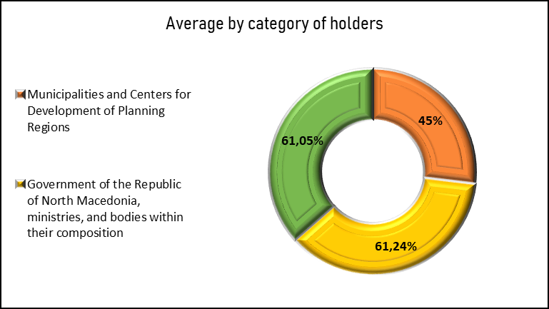

The summarized results of the conducted monitoring indicate that institutions show an average level of proactive transparency of 56%. This percentage, although a slight increase compared to previous monitoring, signals that there is considerable room for improvement. The improvement of proactive transparency is insufficient to warrant a substantial change in the culture of openness; on the contrary, the data indicate that institutions continue to face challenges in ensuring consistency and systematicity in the application of transparency mechanisms. In that direction, it is of crucial importance that the holders of information not only fulfill their formal legal obligations, but also develop internal standards and coordinated practices that enable regular, complete, and understandable communication with the public. Consistency in the publication of public information, combined with the practice of inter-institutional data exchange, is are important prerequisite for building trust and strengthening citizens' awareness of the importance of accountability in institutional operations.

In relation to the Government of the Republic of North Macedonia, its ministries, and the bodies within it, the level of transparency and accountability has also been assessed as high, with proactive transparency, indicating the maintenance of generally good practices in this segment of the right to access public information. The monitoring revealed that the majority of these institutions demonstrate very good transparency, which is a positive indicator of their institutional readiness to adhere to the principles of openness in their operations. However, the Agency's recommendation remains that holders should continue to consistently respect and improve transparency and accountability standards, because only through consistent and proactive application of those standards can it be guaranteed that the work of the institutions will be fully accessible and understandable to the end users - citizens and other public information requesters. Such an approach not only facilitates access to information but also strengthens the democratic capacity of society, building a culture of trust and mutual responsibility.

**ACTIVITIES OF THE AGENCY IN THE PERIOD JANUARY-JUNE:**

In order to increase transparency, but also the work of the institutions in terms of access to public information, the Agency prepared Analyzes of the Agency's handling of complaints received in the period from January 1 to June 30, 2025, with special reference to the silence of the administration, Free access to public information in the countries of the Western Balkans: The silence of the administration as a systemic obstacle to transparency and Comparative analysis of active transparency for 2021, 2023 and 2025 of public enterprises under municipal jurisdiction. They are published on the website of the Agency: <https://aspi.mk/analizi/>

Also, monitoring was carried out on the websites of the holders of information from public enterprises under the jurisdiction of the municipalities and the Government of the Republic of North Macedonia for the year 2025, of state institutions and municipalities, and centers for the development of planning regions. The reports from the same source are published on the Agency's website, <https://aspi.mk/izvestai/>, and have been delivered to the holders with the obtained results, for their familiarization and improvement of web pages in terms of active transparency.

In this reporting period, the Agency had activities both domestically and internationally. In the organization of the office of the Council of Europe in Skopje, a round table was held on the topic: "Analysis of the case law of the Administrative Court (2019-2023) and the impact of the Tromso Convention on the transparency of institutions", as part of the project "Protection of freedom of expression and freedom of the media in North Macedonia (PRO-FREX)", which is part of the joint program of the European Union and the Council of Europe "Horizontal Facility for the Western Balkans and Turkey" 2023-2026" (Horizontal Facility III). At the roundtable, the findings of the analysis of the Administrative Court's case law regarding the Law on Access to Public Information (2019-2023), prepared in collaboration with the Agency for the Protection of the Right to Free Access to Public Information, were presented. The analysis is published on the website: [https://aspi.mk/wp-content/uploads/2025/02/анализа-на-судската-пракса-на-управниот-суд-со-законот-за-слободен-пристап-до-информациите-од-јавен-карактер.pdf](https://aspi.mk/wp-content/uploads/2025/02/%D0%B0%D0%BD%D0%B0%D0%BB%D0%B8%D0%B7%D0%B0-%D0%BD%D0%B0-%D1%81%D1%83%D0%B4%D1%81%D0%BA%D0%B0%D1%82%D0%B0-%D0%BF%D1%80%D0%B0%D0%BA%D1%81%D0%B0-%D0%BD%D0%B0-%D1%83%D0%BF%D1%80%D0%B0%D0%B2%D0%BD%D0%B8%D0%BE%D1%82-%D1%81%D1%83%D0%B4-%D1%81%D0%BE-%D0%B7%D0%B0%D0%BA%D0%BE%D0%BD%D0%BE%D1%82-%D0%B7%D0%B0-%D1%81%D0%BB%D0%BE%D0%B1%D0%BE%D0%B4%D0%B5%D0%BD-%D0%BF%D1%80%D0%B8%D1%81%D1%82%D0%B0%D0%BF-%D0%B4%D0%BE-%D0%B8%D0%BD%D1%84%D0%BE%D1%80%D0%BC%D0%B0%D1%86%D0%B8%D0%B8%D1%82%D0%B5-%D0%BE%D0%B4-%D1%98%D0%B0%D0%B2%D0%B5%D0%BD-%D0%BA%D0%B0%D1%80%D0%B0%D0%BA%D1%82%D0%B5%D1%80.pdf)

The implementation of the Twinning Light project "Supporting free access to information - We rise together" has begun (14.05.2025 - 18.04.2026), which the Agency will implement in cooperation with partners from the German Foundation for International Legal Cooperation (IRZ) and with the financial support of the delegation of the European Union in the Republic of North Macedonia. This project represents a significant step towards improving institutional capacities and strengthening the system for access to public information.

The Agency, in cooperation with the National Democratic Institute, which implements the "Communities with Integrity" Project, and supported by the Governments of Switzerland and Sweden, organized a workshop dedicated to improving the application of the Law on Free Access to Public Information. Officials and heads of the municipalities: Bitola, Bogovinje, Gazi Baba, Kumanovo, Strumica and Shtip, who are part of the project, with interaction and active participation through practical examples from everyday work regarding free access to public information, improved their knowledge of national legislation and international standards and emphasized that access to information is a key tool for increasing transparency, for encouraging cooperation, as well as active involvement of citizens in local processes.

At the International Conference of Information Commissioners (ICIC 2025), held from June 23 to 25, 2025, in Berlin, Germany, the new European Network for Transparency and Right to Information (ENTRI), of which the Agency is an active member, was officially established. Over the next three-year period, the network will be chaired by the German Federal Commissioner for Data Protection and Freedom of Information (BfDI). An executive board will be elected, and the Charter of the European Network for Transparency and Right of Access to Information will be adopted. The agency confirms the state's commitment to promoting transparency and consistent respect for the public's right to have access to public information. Through its active participation, North Macedonia becomes part of a new European initiative aimed at promoting regional and cross-border cooperation, strengthening transparency, and enhancing the accountability mechanisms of public institutions.

In the organization of the Balkan Investigative Reporters Network (BIRN), on June 30, 2025, the online event "The state of free access to information in the Western Balkans - Review for 2024" was held. The event was supported by the Austrian Development Agency, and the director of the Agency for Protection of the Right to Free Access to Public Information, Plamenka Bojcheva, was in attendance. Investigative journalists, who utilize this right in their work, shared and exchanged their experiences, as did representatives of related institutions from all six countries in the region that are part of this network. Practical experiences related to the appeal procedure, supervisory mechanisms, and the implementation of the right to free access to public information were shared. The BIRN report highlights that for the second consecutive year, North Macedonia has achieved the best results in implementing free access to public information.

The Agency will continue to work on implementing access to public information more efficiently, in cooperation with both holders and information requesters. It helps citizens better understand the functioning of institutions, their rights and obligations, and how they can influence the decisions that affect their daily lives and work, as well as the holders, because they will manage the information they have more efficiently and effectively.

Made by:

Melanie Ibraimi

Oliver Serafimovski