

**AGENCY FOR THE PROTECTION OF THE RIGHT TO FREE ACCESS TO PUBLIC INFORMATION**



**COMPARATIVE ANALYSIS OF ACTIVE TRANSPARENCY FOR 2021, 2023, AND 2025 OF PUBLIC ENTERPRISES UNDER MUNICIPAL JURISDICTION**





**Skopje, April 2025**

The methodology of the statistical quantitative analysis relies on data obtained from the monitoring conducted in 2021, 2023, and 2025.

A representative sample of 21 information holders from the institutions monitored so far, founded and under the jurisdiction of the local self-government units, and their index of active transparency, was taken from the list of holders for this analysis.

The analysis detects the state and performance of these institutions in terms of transparency and accountability to citizens over the past period.

The goal is to evaluate the degree to which citizens are proactive in informing themselves by publishing public information on their web pages.

**Key findings by year:**

The biggest oscillations are noted among high-level enterprises - some are declining, while others are making progress. This refers to an **inconsistency in maintaining transparency standards**.

**2021**

* **22 enterprises** had a **very low** level of transparency
* **5 enterprises** with a **low** level
* **8 enterprises** with an **average** level
* **3 enterprises** with a **high** level
* Monitoring the holders' web pages revealed a low level of transparency, but there was no significant percentage difference between the monitored holders.

**2023**

* There is a noticeable increase in **the average level** of transparency.
* **The high-level** notes **insignificant decline**.
* **Low transparency** remains dominant among some of the owners.
* Specific indicators:
  + 2 companies retained their **high transparency**
  + 6 enterprises remained at the **middle level**
  + 1 company left with a **low level**
  + 1 company returned from **high to low**, and the other from **high to high level of transparency**

**2025**

* The general level of monitored holders is moving towards a **medium level of transparency**
* **4 enterprises** stay at a **low level**
* 1 company **reduced transparency** (lack of public information published on the website)
* 1 enterprise, for **three years in a row,** maintains **the highest level of transparency**
* 1 company **transitioned from low to high level, two years in a row**
* 2 enterprises remain in the **second year in a row** with **a low level of transparency**

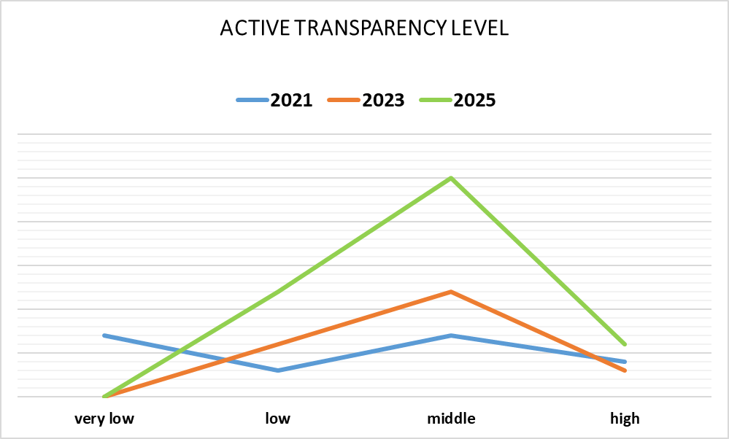

On the graphic display, it can be observed that all these oscillations in the work of the institutions are reflected in a percentage jump in the index of transparency and accountability. A significant difference is observed among holders with a low level of transparency. Only four holders have a low level of transparency for all three years, while the rest remained with a medium or low level. The analysis shows that the owners should invest more in the publication of information on their web pages, which will show accountability in their work, and thus bring their work closer to their end users, that is, to the citizens.

The lack of published information on websites (such as work reports, budgets, public procurements, acts, and decisions), **insufficient** or poor ICT support, and **non-existent** **institutionalized** **practice** for the publication of public information are the main reasons for the insufficient active transparency of public enterprises under the jurisdiction of local self-government units.

**Recommendations for improvement**

**Institutionalizing transparency**: Introduce internal procedures and assign responsible persons to regularly update websites.

**Technical and educational support** for employees: training on managing web content and publishing information in accordance with legal obligations.

**Public involvement**: Creation of mechanisms for feedback from citizens and monitoring by civil society organizations.

All these recommendations will link active transparency with other accountability and efficiency measures.

**Conclusion**

Although there are positive developments overall, the progress of active transparency is **inconsistent and fragmented**. A **more** **intensive** **institutional** **approach** to transparency, with a focus on sustainability, systematicity, and accountability, is needed. Public enterprises should recognize transparency as **a strategic** **component** **for** **trust** **and efficiency**, not just as a formal obligation.

**Authors:**

**Melanie Ibraimi**

**Oliver Serafimovski**