

**AGENCY FOR THE PROTECTION OF THE RIGHT OF FREE ACCESS TO PUBLIC INFORMATION**

**REPORT ON THE VERIFICATION OF THE PUBLISHED DOCUMENTS AND INFORMATION THAT THE PUBLIC ENTERPRISES UNDER THE JURISDICTION OF THE MUNICIPALITIES AND THE GOVERNMENT OF THE REPUBLIC OF NORTH MACEDONIA, AS INFORMATION HOLDERS, ARE OBLIGED TO PUBLISH ON THEIR WEBSITES**

Skopje, April 2025

**CONTENTS:**

INTRODUCTION: 3

WHAT IS PROACTIVE TRANSPARENCY? 4

SUBJECT OF MONITORING: 5

PURPOSE OF MONITORING: 6

FOLLOW-UP FREQUENCY: 6

FRAME OF REFERENCE: 6

RESULTS OF THE MONITORING: 7

First group: ACCESS TO INFORMATION 13

Second group: ORGANIZATIONAL SETTING 15

Third group: OPERATIONAL 17

Fourth group: BUDGET, FINANCIAL OPERATIONS AND PUBLIC PROCUREMENT 19

CONCLUSIONS AND RECOMMENDATIONS: 24

APPENDIX 1: 26

ANNEX 1: Table with the results of the monitoring of public enterprises under the authority of the municipalities and public enterprises under the authority of the Government of the Republic of North Macedonia for the year 2025 26

ANNEX 2: Questionnaire for public information brokers regarding active transparency 28

**Authors: Oliver Serafimovski**

**Melanie Ibraimi**

**Graphic processing: Dean Jadrovski**

# **INTRODUCTION:**

Public information is available to citizens in two ways - with the institutions' proactivity and with reactive means, that is, by submitting a request for information from certain public institutions. Proactive transparency implies the timely publication of public information by institutions that do so on their initiative, before they are requested orally, in writing, or electronically, through clear, transparent, and easily accessible web pages that contain all the information of importance to citizens. Such proactive publication of information contributes to the strengthening of the law. It enables the public to become familiar with regulations, decisions, policy-making, and other actions that are of their interest and affect them.

All the institutions' obligations to make their work transparent also apply to public enterprises under the jurisdiction of the municipalities and the City of Skopje and public enterprises under the jurisdiction of the Government of the Republic of North Macedonia, as holders of public information. Institutions work in the interest of citizens to ensure conditions for their development through transparent operation. For that reason, it is important that citizens are promptly informed about all information of importance to the public, and the holders are obliged to provide citizens with access to that information.

The general goal of the monitoring was to determine the level of proactive transparency of this group of information holders, and in this report we present the findings of the monitoring which examined the extent of the published information that is relevant to citizens, about the annual reports on their work, whether they provide accurate, precise and complete data to the information requesters, whether the holders have a designated official to mediate with the public information, as well as numerous other questions based on which the application of the standards for proactive transparency, under Article 10 of the Law on Free Access to Public Information.

# **WHAT IS PROACTIVE TRANSPARENCY?**

When the holders of public information are open to the public, citizens find out what and how the state government bodies, other establishments, and institutions work. This enables them to participate equally in public life and control the authorities' work.

The proactive publication of public information is a legal obligation of all holders. On their own initiative and continuously, they are required to publish information on their web pages about their work and actions, decision-making, finances, and the services they provide to citizens.

The goal of fulfilling the obligation to proactively publish information is reflected in the opportunity for citizens/information requesters to exercise the constitutionally guaranteed right of access to information through the possibility of information and services being available to information holders quickly and straightforwardly. At the same time, the information holders receive the necessary legitimacy because they demonstrate responsibility in their work, thus restoring the citizens' trust in the institutions.

With the proactive publication of public information, the legal obligation is established for the holders to respond to the submitted requests concerning the Law on Free Access to Public Information and publish public information on their web pages, without the requesters requesting it. Proactive publication of public information is an integral part of the right to access, thus ensuring holders' timely availability of key information. As stated by the European Court of Human Rights, which recognizes it as a fundamental human right, "information is changeable and any delay in its publication, even for a short period, may reduce its overall value and interest in it."

The holders' actively published information should be easily accessible, understandable, usable, relevant to citizens, and regularly updated. Information is a prerequisite for responsible government and a basis for democratic processes—information about the holders' work enables citizens to draw conclusions adequately and participate in decision-making on issues of public interest. Transparency and access to public information are inseparable instruments in the fight against corruption.

A significant advantage of proactively releasing public information, especially when done immediately, is that it makes it more difficult for information holders to deny the existence of the information or manipulate it. This means that all citizens/requesters of public information save time, money, and effort through the possibility of proactive availability of information. The principle of equality enables the realization of this right, fulfillment of obligations, and participation in political, social, and economic processes, all strengthening trust in institutions. The low proactivity of publishing information makes it impossible for the public to monitor, control, and participate in the work of information holders.

# **SUBJECT OF MONITORING:**

The monitoring is focused on checking the categories of information that should be regularly updated and published on the websites of the holders of public information following the provisions of Article 9 and Article 10 of the Law on Free Access to Public Information (LFAPI).

# **PURPOSE OF MONITORING:**

The purpose of the monitoring is to detect the conditions in implementing the obligation of the holders of public information to publish the 22 categories of information on their websites proactively. It helps in realizing the competence of the Agency for the Protection of the Right of Free Access to Public Information for implementing the provisions of LFAPI and increasing the capacities of the holders of public information concerning their greater transparency and openness. Also, the monitoring will contribute to a better identification of the training needs of the officials among the information holders.

# **FOLLOW-UP FREQUENCY:**

The monitoring frequency can be once a year, twice a year, or over a longer period. However, to ensure the comparability of the results and to use them to identify problems, training needs, and strategies for the agency's work, the monitoring must be carried out within a certain time frame.

# **FRAME OF REFERENCE:**

The reference framework for monitoring should be the questionnaire developed specifically for that purpose, based on the categories listed in Article 10 of the LFAPI. The questionnaire for this group of holders contains 35 questions and sub-questions. All the questions to the information holders stem from Article 10 of the LFAPI, and through the said questions, the holders carry out a self-evaluation of their web pages and their proactivity, i.e., whether and to what extent they publish the necessary information that is of interest to the citizens.

# **RESULTS OF THE MONITORING:**

The Agency, following its competences, but also as an added value of free access to public information concerning the proactive publication of information under Article 10 of the Law on FAPI, conducted monitoring of 43 holders, i.e. on the websites of holders from public enterprises under the jurisdiction of the City of Skopje and the municipalities, as well as public enterprises under the jurisdiction of the Government of the Republic of North Macedonia, which are part of the holders published on the List of holders of information on the Agency's website. Thirty-one holders under the jurisdiction of the municipalities and 12 holders who are responsible for their work to the Government of the Republic of North Macedonia were monitored.

|  |  |
| --- | --- |
| **In municipal jurisdiction** | |
| **PE for the welfare of stray animals "Lajka"-Skopje** | www.lajka.com.mk |
| **Public enterprise for municipal waste disposal "Drisla"-Skopje** | www.drisla.mk |
| **PE Water supply and sewerage – Prilep** | [vodovod-prilep.mk/](https://vodovod-prilep.mk/) |
| **PCE Vodovod-Kumanovo** | [www.vodovod-kumanovo.com.mk/](http://www.vodovod-kumanovo.com.mk/) |
| **PCE Derven - Veles** | [www.derven.mk/](http://www.derven.mk/) |
| **PE "Water and sewerage"-Skopje** | [www.vodovod-skopje.com.mk](http://www.vodovod-skopje.com.mk/) |
| **PE "City Parking"-Skopje** | [www.gradskiparking.com.mk](http://www.gradskiparking.com.mk/) |
| **PE "Parks and greenery"-Skopje** | [www.parkovi.com.mk](http://www.parkovi.com.mk/) |
| **PE "Streets and Roads"-Skopje** | [uip.gov.mk/](http://uip.gov.mk/) |
| **PE "Communal hygiene" - Skopje** | [www.khigiena.com.mk](http://www.khigiena.com.mk/) |
| **PE "Ohrid municipal utility" - Ohrid** | [www.ohridskikomunalec.com.mk](http://www.ohridskikomunalec.com.mk/) |
| **PE for the construction, maintenance, and use of public parking spaces, Strumica-Strumica parking lots** | [www.strumicaparking.mk](http://www.strumicaparking.mk/) |
| **Public utility company "Komunalec"-Prilep** | [komunalecprilep.com.mk](http://komunalecprilep.com.mk/) |
| **Public enterprise "Komunalec"-Bitola** | [www.komunalecbt.com.mk](http://www.komunalecbt.com.mk/) |
| **Public enterprise Vodovod- Ohrid** | [www.vodovod-ohrid.com.mk](http://www.vodovod-ohrid.com.mk/) |
| **Public enterprise for energy activities "Strumica-gas" - Strumica** | [www.strumicagas.mk](http://www.strumicagas.mk/) |
| **Public enterprise for public parking lots, PARKING KAVADARCI, Kavadarci** | [www.jpparkingkavadarci.mk](http://www.jpparkingkavadarci.mk/) |
| **Public enterprise for public parking lots, Parking lots of the Municipality of Centar** | [www.poc.mk](http://www.poc.mk/) |
| **Public enterprise for communal activities - "Komunalec-Polin" - Dojran** | [www.komunalecpolin.mk](http://www.komunalecpolin.mk/) |
| **Public company for communal works "Sluzhno"-Berovo** | [jpkrusluga-berovo.com.mk/FastPayment.aspx](https://jpkrusluga-berovo.com.mk/FastPayment.aspx) |
| **Public enterprise for spatial and urban plans "Kumanovo Plan"- Kumanovo** | [www.kumanovoplan.gov.mk](http://www.kumanovoplan.gov.mk/) |
| **Public enterprise for spatial and urban planning Prilep** | [jpzapup.com](http://jpzapup.com/) |
| **Public enterprise "Kumanovo-Gas"- Kumanovo** | www.kumanovogas.com.mk |
| **Public transport company "Skopje"** | [www.jsp.com.mk](http://www.jsp.com.mk/) |
| **PUC "Vodovod" - Bitola** | [vodovodbt.mk/mkd/kontakt.html](http://vodovodbt.mk/mkd/kontakt.html) |
| **PUC "GAZI BABA-2007"- Skopje** | [www.jkpgb2007.gov.mk](http://www.jkpgb2007.gov.mk/) |
| **PUC "Tetovo"- Tetovo** | [www.npktetova.mk](http://www.npktetova.mk/) |
| **PE "City Parking and Greenery" - Gostivar** | [parkingjet.mk](http://parkingjet.mk/) |
| **PE for communal production and service activities "ISAR"-Stip** | [jpisar.com.mk/](http://jpisar.com.mk/) |
| **PCE Vodovod-Kočani** | [www.vodovodkocani.com.mk](http://www.vodovodkocani.com.mk/) |
| **PCE "Komunalec" – Strumica** | <https://komunalec-strumica.com.mk/> |
| **Under the jurisdiction of the the Republic of North Macedonia Government** | |
| **Railways of the Republic of North Macedonia Transport AD-Skopje** | www.mzt.mk/za nas/informacii od javan character |
| **PE for the management and protection of the multipurpose area Jasen - Skopje** | [www.jasen.com.mk/](http://www.jasen.com.mk/) |
| **PE "Official Gazette of the Republic of North Macedonia" - Skopje** | [www.slvesnik.com.mk](http://www.slvesnik.com.mk/) |
| **PE for management of state forests, National forests - Directorate-Skopje** | [www.mkdsumi.com.mk](http://www.mkdsumi.com.mk/) |
| **Public enterprise "Strezevo"-Bitola** | [www.strezevo.com.mk](http://www.strezevo.com.mk/) |
| **Public enterprise for railway infrastructure, Railways of the Republic of North Macedonia - Skopje** | [mzi.mk/](https://mzi.mk/) |
| **Public enterprise for stock exchange operations "Agro-Berza"-Skopje** | [www.agroberza.com.mk](http://www.agroberza.com.mk/) |
| **Public Enterprise for State Roads** | [www.roads.org.mk](http://www.roads.org.mk/) |
| **Public Broadcasting Company Macedonian Radio-Television- Skopje** | [www.mrt.com.mk](http://www.mrt.com.mk/) |
| **PE "National Radio Broadcasting" - Skopje** | [www.jpmrd.gov.mk](http://www.jpmrd.gov.mk/) |
| **PE for protection and maintenance of main and regional roads - Skopje** | [www.makedonijapat.com.mk](http://www.makedonijapat.com.mk) |
| **Public enterprise for water supply "Studenchica"-Kichevo** | [www.studencica.com.mk](http://www.studencica.com.mk) |

The monitoring was carried out from March 27 to April 25, 2025, and the cooperation and analysis department in the Agency was in charge of monitoring the websites for the full publication of the documents and information that the holders of information are obliged to publish according to Article 10 of the Law. We note that the monitoring does not analyze the content and quality of the published information.

The monitoring was carried out according to a methodology implemented in cooperation with external experts, hired by the IPA II Project "Transparency and Accountability of Public Administration", whose beneficiary is the Agency. A questionnaire containing 35 questions was drawn up, deriving from Article 10 of the Law. Some include one or more sub-questions; the maximum number of possible points is 56. Holders of published data receive 0, 0.5, and 1 point, depending on the number and up-to-dateness of the published documents. The questionnaire was distributed to the holders, who were asked to evaluate their transparency and return the questionnaires to the Agency.

Within the deadline for submitting the answers to the Agency (April 9, 2025), a total of 28 holders submitted answered questionnaires, whose officials in the self-evaluation gave answers that contained links to specific documents as provided by the questionnaire for monitoring web pages.

Also, on the website of the Agency, news was published about the start of the monitoring and what will be its purpose [https://aspi.mk/новости/агенцијата-за-заштита-на-правото-на-сл-4/](https://aspi.mk/%D0%BD%D0%BE%D0%B2%D0%BE%D1%81%D1%82%D0%B8/%D0%B0%D0%B3%D0%B5%D0%BD%D1%86%D0%B8%D1%98%D0%B0%D1%82%D0%B0-%D0%B7%D0%B0-%D0%B7%D0%B0%D1%88%D1%82%D0%B8%D1%82%D0%B0-%D0%BD%D0%B0-%D0%BF%D1%80%D0%B0%D0%B2%D0%BE%D1%82%D0%BE-%D0%BD%D0%B0-%D1%81%D0%BB-4/). The web pages of the monitored holders are different in appearance and in terms of their content and published information. It should be emphasized that the information holders' websites are updated according to their activities and function as the first informant for the citizens, as well as for the services they provide. However, we should emphasize that what is intended for easy access to public information, i.e., the availability of the information published in the List of Information, is not published on the home page of the majority of the web pages of the holders, so that access to the same is slow and insufficiently accessible. The information should be quickly available with a maximum of three clicks by the information seeker. Most often, the institutions move the public information, the link to it, to links such as contact, public relations, and similar sections of the web pages. We also want to emphasize that unsystematized information creates confusion among citizens, because information is more difficult to access. This means that the web pages with the information published on them should be easily accessible, so the searchers can provide the information they need more simply. Therefore, we suggest to the holders of the information that their information published on the web pages be easily accessible for the citizens, as the maxim "Informed citizens, satisfied citizens" says, that is, transparent institutions that are at the service of the citizens.

All these points point to the need for web pages to be visually and structurally arranged and functionally designed for easy accessibility. The information that citizens need, which is part of the legal obligations for transparency of the institutions, must be available quickly and without unnecessary obstacles. Thus, more efficient fulfillment of the right to access public information will be enabled, and citizens' confidence in the transparency of the institutions will be strengthened. Also, with the monitoring, we ascertain that the web pages of the holders are not adapted for the needs of people with disabilities, who are also potential requesters of public information.

Depending on the total number of points that the monitored holders received concerning the published necessary documents and information under Article 10 of the Law, a gradation was made of the degree of fulfillment of the legal obligation for their active transparency, as follows: holders with a low level between 0 and 21.9 points, holders with a medium level between 22 and 43.9 points and with a high level of transparency from 44 to 56 points.

According to the monitoring methodology, 6 of the 43 information holders monitored have a high level of transparency, 25 have a medium level of transparency, and 12 have a low level of transparency. Monitored holders have a mean value of proactive transparency.

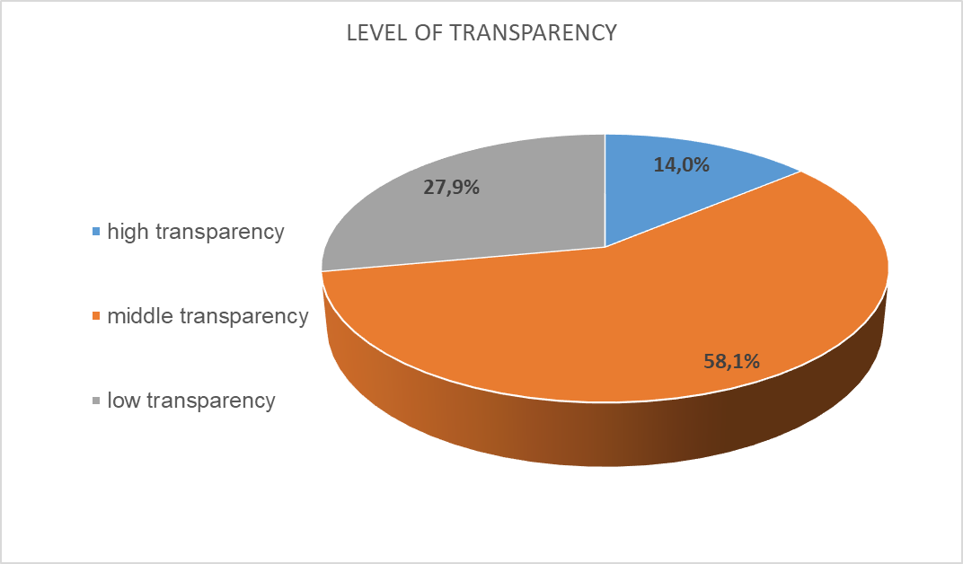

However, this does not mean that the holders should be satisfied with their transparency because the websites of the most significant number of holders from this group of monitored institutions make it difficult to access certain information that interests citizens/public information requesters.

According to the monitoring results, the most transparent holders are: PE Communal hygiene - Skopje with 51.5 points, the Public Enterprise for Railway Infrastructure, Railways of the Republic of North Macedonia - Skopje with 49 points, as well as PCE Derven from Veles with 47.5 points out of a possible 56 points. We should emphasize that the websites of the best-ranked institutions have an easy and accessible way of accessing public information that is of interest to the applicants, and we encourage them to monitor and build on proactive transparency, as well as accountability in their work to citizens.

The lowest transparency in the publication of public information with this monitoring was shown by: PUK TETOVO from Tetovo and PE for energy activities Strumica Gas - Strumica with 1 point each, as well as PE for communal production and service activities "ISAR" from Shtip with only 6 points. These holders should adapt their web pages for the end users of their services, that is, the citizens, because it is difficult or impossible to get information about their work and functioning on their web pages. When the monitoring was carried out, the web pages of PUC TETOVO from Tetovo and PE "City Parking and Greenery" from Gostivar were not active. Hence, they could not be adequately monitored and evaluated for proactive transparency. PUK TETOVO from Tetovo has received only one point because the official at the holder fulfilled the obligation to submit the questionnaire for self-evaluation. The website of J.P. for energy activities Strumica Gas - Strumica, and this monitoring has abysmal results concerning its active transparency, that is, there is a drop of 8.5 points in the evaluation of the published information on its website.

The web pages of the holders of the public enterprises under the jurisdiction of the Government of the Republic of North Macedonia, among others, are monitored and show the best proactive transparency. This shows the tendency to publish public information that interests citizens/applicants and practices proactive publication of public information.

We can emphasize that the overall proactive transparency of the monitored web visitors has not improved concerning the monitoring since 2023, that is, the openness has stagnated, and they have a medium level of transparency, because they do not publish the information in full and for the purposes for which they have jurisdiction.

Based on the monitored web pages and according to the methodology, as well as the Self-evaluation Questionnaire, the following results and indicators for the proactive transparency of the holders were obtained:

## **First group: ACCESS TO INFORMATION**

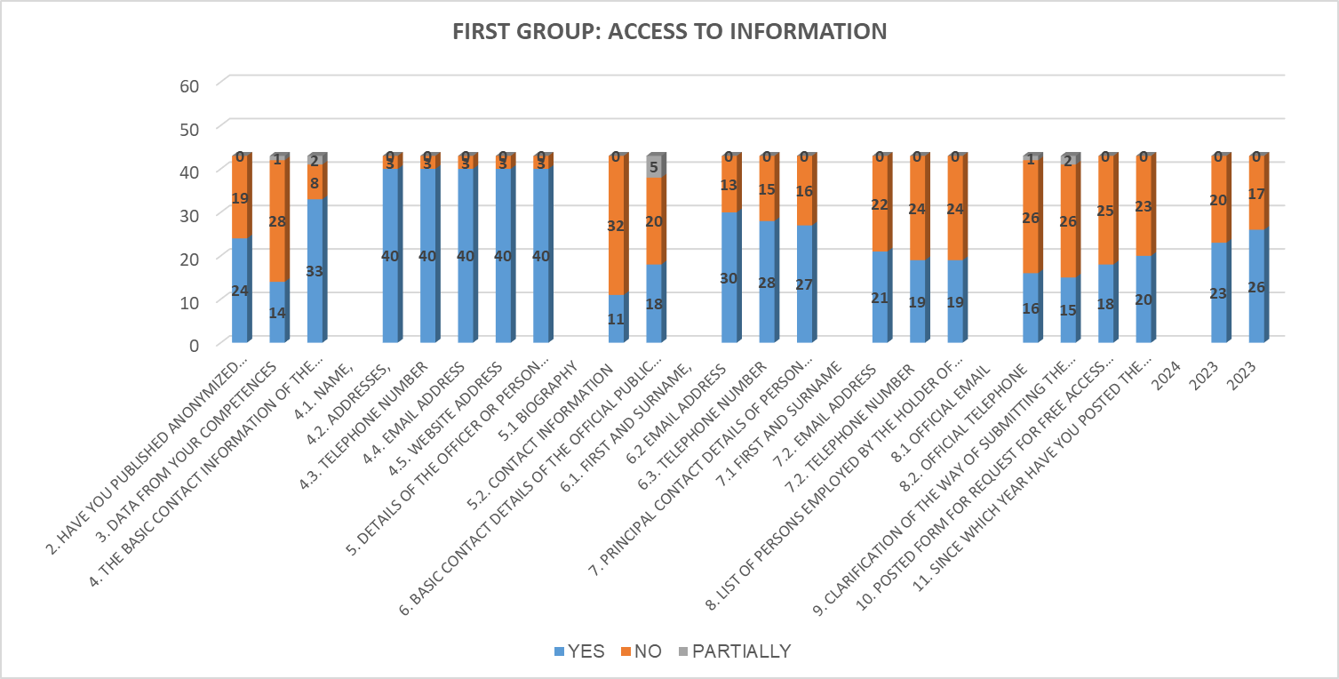

From a total of 43 monitored holders of the first group of questions: ACCESS TO INFORMATION, which contains 11 questions with sub-questions, the following results were obtained for their proactive transparency:

The results show that 24 institutions have moved the PUBLIC INFORMATION banner/link on their homepage, while 19 have not published the public information. On their web pages, as an added value to access to public information, it is a positive practice for the holders to have published anonymized requests/responses for free access. Still, only 14 holders have moved this information, while 28 holders have not published it. One holder has fulfilled this added value by publishing the requests/responses for free access that he received based on the Law on FAPI for only one of the last three years. Thirty-three holders have published information about their competence, while eight do not change this information. Two holders partially publish the data for their jurisdiction. All holders have published the basic contact information with the information holder. The information about the official or the responsible person of the information holder: biographies on the web pages have been published by only 11 holders, and 32 holders have not published this information. Regarding the official's contact data, 18 holders have published a contact phone number and an official email address, while 20 institutions have not published this data on the website. Five holders have partially moved the contact information for the responsible person.

From the monitoring, we can conclude that in the free access to information link, 30 holders have published the name and surname of the official for mediating the public information. In contrast, 13 institutions have not published this obligation, so that the claimants of these holders are left without data and information to whom to submit their request and thereby exercise their right of access to information. Twenty-eight holders have published official email addresses, and fifteen have not published their contact form. The official contact phone number of the persons to mediate the information was published by 27 holders, while 16 did not comply with this legal obligation.

Data on persons authorized for protected internal reporting, that is, their first and last names, have been published by 21 holders, and 22 have not changed this information. Only 19 holders have published their official email addresses, and 24 have not fulfilled this obligation. Also, 19 holders published their contact phone numbers, while 24 holders did not provide this information. Only 16 institutions have published a list of persons employed by the information holder with official email addresses, and 26 have not published this information. Only 15 holders have published contact information for the official telephone numbers, while 26 do not have this information on their web pages. Three holders have partially published this information about the employees: the official contact numbers and email addresses.

Only 18 holders have complied with this legal provision in the section on clarifying the method of submitting the request for access to information (the process of submitting an oral, written, or electronic request). At the same time, 25 have not published clarifications on access to public information. This information needs to be published to enable, facilitate, and clarify the legal right of access to public information.

20 holders have moved the request form for free access to public information, and 23 have not published it on their websites. Some of the monitored institutions still have the form according to the Law from 2006 and the amendments from 2010/15, which directs the applicants to seek information through a law that is no longer in force. The annual report on access to public information for 2023 has been published on their websites by 26 holders and 23 for 2024, while 17 have not published it for 2023 and 20 have not published it for 2024, under Article 36 of LFAPI.

**Second group: ORGANIZATIONAL SETTING**From the second group of questions: ORGANIZATIONAL SETTING, the monitored 43 holders show a low level of transparency, and this can also be seen from the table:

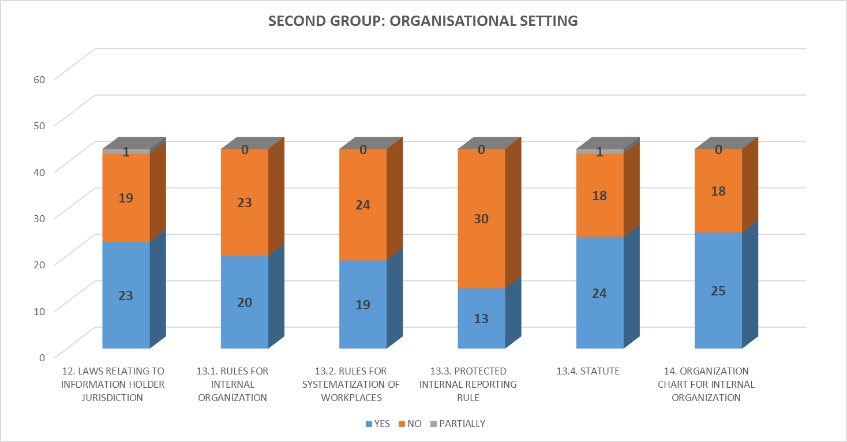

Twenty-three holders have published the laws relating to the competence of the information holder, with which the citizens, that is, the claimants, can familiarize themselves with the basic information on the basis of which the holders of public enterprises work. One institution, in the laws link, has moved only part of the law; that is, it has been published as part of the institution's requirements. Nineteen holders have not published the rules that apply to their jurisdiction on their websites.

In the section in which the holders inform about the Regulations they carry within their jurisdiction in the form of a by-law, which refer to: the rules for internal organization, only 20 holders have published it, and 23 have not published this document. The rulebook for the systematization of workplaces has been published on the web pages by a small number of institutions - 19 entities, and for as many as 24 institutions, it cannot be found on the web pages, that is, it has not been published. Twenty-four holders have published the enterprise statute, and 18 have not, so it is available to the citizens/requesters of information. Only one owner has published this document partially; that is, it is not fully published on the website. Of the monitored holders, only 13 institutions have published the rulebook for protected internal reporting, and as many as 30 holders have not set it up. The organogram for internal organization has been published on the web pages by 25 holders from public enterprises, and 18 institutions have not published this information.

## **Third group: OPERATIONAL**

In the third OPERATIONAL group of questions, which refers to information from the scope of their work and contains 10 questions and sub-questions, the monitored holders have a proactive transparency that should be significantly improved.

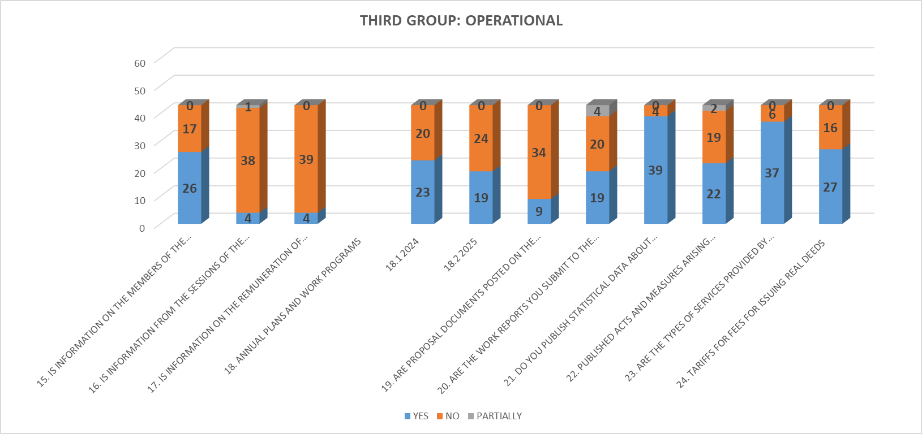

The websites of the monitored enterprises also lack data on information from the sessions of the management and supervisory boards, where only 4 holders have published this information, and the same number of holders have published information relating to data on the remuneration of the members of the management and supervisory boards. Only one holder partially publishes this information. The monitored holders publish only the names of the members of the management and supervisory boards, and that is 26 holders, and 17 institutions do not publish this data on their web pages. This information is per the standards provided by the OECD Guide.

23 holders have published annual plans and work programs for 2024, while 20 have not published this type of document. While only 19 holders have published the annual work plans and programs for 2025, 24 institutions have not published this information.

Proposals of documents (proposals of programs, programs, views, opinions, studies) have been published on the web pages by only 9 holders, and as many as 34 have not published the necessary documents. By not publishing this information, citizens/information requesters are prevented from getting to know how public enterprises plan to work, to publish their views and opinions that are within their competence, but also crucial for their work.

On the web pages, in the section where the holders publish the reports on the work that they submit to the supervisory authorities, 19 holders have published the reports, thus giving an account of their work, and 20 institutions have not published this information that is of interest to the information requesters. Some holders, or four holders, publish the reports as six-monthly or quarterly reports for the current year.

The monitoring showed that 39 holders have moved this type of information, including statistical data on the work and other information, and four institutions do not publish this data on their websites.

The monitoring showed that the holders publish acts and measures resulting from the authority and work of the holder on their web pages. Still, this obligation should be announced to all monitored holders. Citizens can access information about their interests through links and access to it, and 22 institutions publish it. On the other hand, 19 institutions do not publish this information. Two holders publish this information partially on their pages.

The holders publish the most information about the types of services they provide to applicants, namely 37 institutions, while six holders do not publish this data on their websites. In the section where the holders inform the citizens about the tariff lists for fees for issuing real acts, 27 of them inform the citizens, and this is the most important information for them. Even 16 holders did not publish this important information, which prevents the citizens from getting to know their content.

## **Fourth group: BUDGET, FINANCIAL OPERATIONS, AND PUBLIC PROCUREMENT**

According to the monitoring, the proactive transparency of the holders in the fourth group of issues: BUDGET, FINANCIAL OPERATION, AND PUBLIC PROCUREMENT, is of a medium level. This remark is because the interest of the citizens is directed mainly towards the financial operations of the institutions, especially in the part of the published budgets, financial reports, audit reports, and the publication of information and documents related to public procurement. There is also information regarding concessions and agreements for them, as well as public-private partnership agreements, which in this group of information, the holders publish at least or not at all on their websites, and thus do not inform the citizens/requesters as end users of these services.

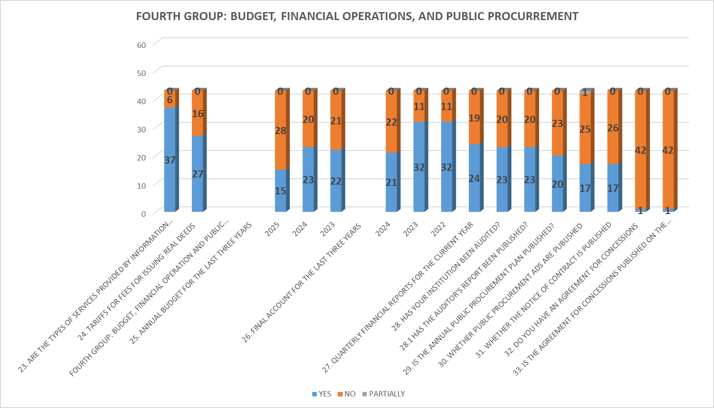

The last three years (2023, 2024, and 2025) were monitored in the part that refers to budget transparency. Twenty-two institutions have published information about the budget for 2023, and from 21 institutions, this information has not been posted on the pages. For 2024, 23 holders have published their budgets, while 20 have no information regarding this legal obligation. Only 15 holders have published information about the budget for 2025, and even 28 have not uploaded this information on their websites.

It should be noted that public enterprises move the information related to this group of documents into their work programs and investment programs. Still, for citizens/applicants to access them more easily, they need to be moved to the web pages as separate documents that refer to their financial operations.

Regarding the information related to the publication of the final accounts for the last three years (2022, 2023, and 2024), the institutions show a trend of good proactive transparency. For 2022 and 2023, 32 holders have published the information, while the pages of 11 holders are missing this data.

The trend of publishing the final accounts for 2024 decreased. Only 21 holders fulfilled the legal obligation, and 28 did not report any information related to fiscal transparency. Twenty-four holders have published quarterly financial reports for the current year, while 19 institutions have not published them on their websites.

We would like to point out to the monitored holders that they should not publish the budgets in PDF, but in open-Excel format so that they are viewable and usable for citizens and public information requesters. With this way of publishing, the holders will follow the world trend of publishing this information in an open format. With that, the information becomes usable for applicants who do analyses and other reports, making finances more accessible to citizens.

Through the publication of this key financial document, citizens will be informed about the institutions' plans regarding how economic resources will be spent and distributed for their operations. The publication of this information prevents potential corruption, and the reportable publication reduces the risk and suspicion of possible corrupt acts.

Regarding information about the audit performed, 23 institutions publish the audit reports, while 20 holders do not publish the reports on their web pages. The audit report is an essential document for citizens/applicants, through which they can inspect the operation of the institutions, see the remarks made in these reports, and see if the institution has acted on the findings in them.

The monitoring results also showed that in the section on public procurement, the holders should be much more proactive and publish these documents. Only 20 institutions have published the annual public procurement plan, while 23 holders have not posted it on their websites. By not publishing the plan, citizens cannot see what information holders have predicted they need for their current operations.

The non-disclosure of the annual plan creates suspicion of possible corrupt actions among the holders. Public enterprises demonstrate their accountability concerning public procurement by proactively publishing the yearly plan for public procurement. A large number of holders state that they have published the annual plan, but the indicated link leads to the home page of the electronic public procurement system <https://www.e-nabavki.gov.mk/PublicAccess/Home.aspx#/home>

Only 17 holders published public procurement announcements for 2024, while 25 institutions did not link the necessary information. One holder has partially fulfilled this obligation; that is, the information has not been published.

The same applies to information about the notifications of concluded contracts. Seventeen holders fulfilled this obligation, while 26 institutions did not publish the notification. The publication of information in the public procurement section is one of the basic parameters in the institutions' anti-corruption operations, and also increases citizens' confidence in their operations.

In the last set of questions, which refer to concluded agreements for concessions and published agreements for them, only one holder has published the concluded contract. Regarding information related to concluded agreements for public-private partnership and their publication, none of the 43 monitored public enterprises publishes this information on their websites.

Each monitored owner also receives points for the submitted Self-Evaluation Questionnaire on the website, and answered questionnaires with links to the published information were submitted by the following holders:

1. J.P. Ohrid Kommunalec-Ohrid
2. JP Official Gazette of the Republic of North Macedonia
3. JP AGRO-BERZA Skopje
4. JP National Broadcasting-Skopje
5. JSP Skopje Skopje
6. PUK Gazi Baba in 2007
7. JPKD Komunalec-Strumica
8. Public enterprise Parks and greenery - Skopje
9. JP Parking lots Strumica - Strumica
10. JPKR Service Berovo
11. Public enterprise for spatial and urban plans KUMANOVO PLAN Kumanovo
12. PE National Forests
13. PE for public parking lots, PARKING Kavadarci
14. JP Studenchica Kicevo
15. PUC "Water and Sewerage" Prilep
16. PUC Derven - Veles
17. Public Enterprise for State Roads
18. PUK Vodovod Bitola
19. PUC "Tetovo-Tetovo
20. Public enterprise for railway infrastructure, Railways of the Republic of North Macedonia
21. JKP Communal - Prilep
22. JP STREZEVO Bitola
23. JP Water and sewerage - Skopje
24. JP Communal Hygiene - SKOPJE
25. JP Landfill Drisla Skopje
26. Public enterprise for spatial and urban planning - Prilep
27. Public utility company BITOLA
28. PE Streets and Roads - Skopje

# **CONCLUSIONS AND RECOMMENDATIONS:**

This year, the level of transparency and accountability in the operation of public enterprises under the jurisdiction of the City of Skopje, local self-government units, and the Government of the Republic of North Macedonia has been assessed at an "intermediate level" of transparency. However, there is a trend of stagnation, especially concerning the proactive publication of public information. The monitoring showed that most institutions show an average value of transparency. Still, it is necessary to improve this level; for that, it is required to respect the standards for transparency and accountability consistently. This approach will make institutions more accessible to citizens as end users of public information.

For institutions with a "low" level of transparency, a significantly greater investment is needed in promoting their proactivity towards citizens.

The results of the monitoring showed that the holders will have to increase their transparency, particularly concerning the publication of the following information:

* The regulations that the owner of the information adopts within his jurisdiction in the form of a by-law.
* Information on the members of the management and supervisory boards, from the sessions of the management boards, as well as data on the fees of the members of the management and supervisory boards.
* Budget, financial operations, and public procurement and
* Information on concession agreements and public-private partnerships.

One of the recommendations is to establish a unified and visible banner on their websites with the title "PUBLIC INFORMATION", where all relevant information will be published. This will not only facilitate access for citizens but also reduce the number of submitted requests for free access to information.

Current practice shows that sub-links such as "Free access," "Transparency," or "Public information" are often placed as sub-links to the main link on web pages, and the goal is to get to the requested information quickly.

Therefore, the institutions should regularly update and structure this information and publish it on the home pages following Article 10 of the Law on FAPI and their competences.

Placing a unified banner with a clear structure and regularly updated data will ensure greater information availability. This will allow citizens quick and straightforward access to relevant data, key to strengthening their trust in institutions and active participation in decision-making processes. In addition, this will enable transparent monitoring of the institutions' activities and services.

The Agency for the Protection of the Right to Free Access to Public Information will, as before, continue with continuous training for officials in the institutions, placing special emphasis on active transparency and the consistent application of Article 10 of the Law. They can ask the Agency for help, suggestions, or questions about proactive openness. The trainings will help the officials not only to understand the legal obligations, but also to improve the availability of information that is of public interest.

Active transparency plays a key role in:

* Improving citizens' understanding of the functioning of institutions.
* Enabling citizens to use their rights and obligations.
* Encouraging participation in decision-making that affects their lives.
* Easy access to public services offered by institutions.

Only by continuously improving transparency and accountability will the institutions strengthen citizens' trust and increase the quality of services. Public enterprises can become an example of effective and accountable management through visibility, proactivity, and constant information updating.

# **APPENDIX 1:**

## **ANNEX 1: Table with the results of monitoring public enterprises under the authority of the municipalities and public enterprises under the authority of the Government of the Republic of North Macedonia for 2025.**

|  |  |  |
| --- | --- | --- |
| **RB** | **INSTITUTION** | **POINTS** |
| 1 | P.E. "Communal hygiene" - Skopje | 51,5 |
| 2 | Public enterprise for railway infrastructure, Railways of the Republic of North Macedonia - Skopje | 49 |
| 3 | P.C.E. Derven - Veles | 47,5 |
| 4 | Public Enterprise for State Roads | 46 |
| 5 | Public enterprise for water supply "Studenchitsa"- Kicevo | 45 |
| 6 | Public enterprise "Strezevo"- Bitola | 44 |
| 7 | P.E. "Parks and greenery"- Skopje | 43 |
| 8 | P.E. "Ohrid municipal utility" - Ohrid | 42,5 |
| 8 | P.E. "Official Gazette of the Republic of North Macedonia" - Skopje | 42,5 |
| 10 | Public enterprise for municipal waste disposal "Drisla"-Skopje | 40 |
| 11 | P.E. "Streets and Roads" - Skopje | 39,5 |
| 11 | Public utility company "Komunalec" - Prilep | 39,5 |
| 13 | Public Broadcasting Company Macedonian Radio -Television- Skopje | 38 |
| 14 | JP for management of state forests, National forests - Directorate Skopje | 36,5 |
| 15 | Public company for communal works "Sluzhno"- Berovo | 36 |
| 16 | Public enterprise for spatial and urban plans "Kumanovo Plan"-Kumanovo | 35 |
| 17 | P.C.E. "Komunalec" – Strumica | 33 |
| 18 | Public enterprise for stock exchange operations "Agro-Berza"- Skopje | 31,5 |
| 19 | Public enterprise for spatial and urban planning in Prilep | 31 |
| 20 | P.E. "Water and sewerage"- Skopje | 30,5 |
| 21 | Public enterprise "Komunalec"- Bitola | 29,5 |
| 21 | PUC "Vodovod" - Bitola | 29,5 |
| 23 | P.E. for the construction, maintenance, and use of public parking spaces, Strumica-Strumica parking lots | 28 |
| 24 | Public enterprise for public parking lots, PARKING KAVADARCI, Kavadarci | 27 |
| 25 | P.E. "City Parking"- Skopje | 26,5 |
| 26 | P.E. "National Radio Broadcasting" - Skopje | 26 |
| 27 | Public transport company "Skopje" | 25 |
| 28 | P.E. Vodovod-Kumanovo | 23,5 |
| 29 | P.E. Water supply and sewerage – Prilep | 23 |
| 30 | P.C.E. Vodovod-Kočani | 22,5 |
| 30 | P.E. for the management and protection of the multipurpose area Jasen - Skopje | 22,5 |
| 32 | PUC "GAZI BABA-2007"-Skopje | 21,5 |
| 33 | P.E. for protection and maintenance of central and regional roads - Skopje | 20 |
| 34 | Railways of the Republic of North Macedonia Transport AD-Skopje | 18,5 |
| 35 | PE for the welfare of stray animals "Lajka"- Skopje | 16 |
| 35 | Public enterprise for communal activities - "Komunalec-Polin" - Dojran | 16 |
| 37 | Public enterprise for public parking lots, Parking Lots, of the Municipality of Centar | 14 |
| 37 | Public enterprise "Kumanovo-Gas"- Kumanovo | 14 |
| 39 | Public enterprise Vodovod - Ohrid | 12 |
| 40 | P.E. for communal production and service activities "ISAR"-Shtip | 6 |
| 41 | Public enterprise for energy activities "Strumica-gas" - Strumica | 1 |
| 42 | PUC "Tetovo"-Tetovo | 1 |
| 43 | P.E. "City Parking and Greenery" - Gostivar | 0 |

**LEGEND:**

* **High level of transparency: 6 holders**
* **Medium level of transparency: 25 holders**
* **Low level of transparency: 12 holders**

## **ANNEX 2: Questionnaire for public information brokers regarding active transparency**

|  |
| --- |
| **FIRST GROUP: ACCESS TO INFORMATION** |
| 1. DO YOU HAVE THE LIST OF INFORMATION PUBLISHED ON THE HOME PAGE? |
| 2.  HAVE YOU ANONYMOUSLY PUBLISHED REQUESTS/RESPONSES FOR FREE ACCESS TO PUBLIC INFORMATION ON THE WEBSITE? |
| 3.  DATA FROM YOUR COMPETENCES? |
| **4. THE BASIC DATA FOR CONTACT WITH THE HOLDER OF THE INFORMATION** |
| 4.1. NAME |
| 4.2. ADDRESS |
| 4.3. TELEPHONE NUMBER |
| 4.4. EMAIL ADDRESS |
| 4.5. WEBSITE ADDRESS |
| **5. DETAILS OF THE OFFICER OR PERSON RESPONSIBLE FOR THE HOLDER OF THE INFORMATION** |
| 5.1 BIOGRAPHY |
| 5.2. CONTACT INFORMATION |
| **6. BASIC CONTACT DETAILS OF THE OFFICIAL BROADCASTING PERSON** |
| 6.1. NAME AND SURNAME |
| 6.2. EMAIL ADDRESS |
| 6.3. TELEPHONE NUMBER |
| **7. PRINCIPAL CONTACT DETAILS OF PERSON AUTHORIZED FOR PROTECTED INTERNAL REPORTING** |
| 7.1 FIRST AND SURNAME |
| 7.2. EMAIL ADDRESS |
| 7.2. TELEPHONE NUMBER |
| **8. LIST OF PERSONS EMPLOYED BY THE HOLDER OF THE INFORMATION WITH POSITION** |
| 8.1 OFFICIAL EMAIL |
| 8.2. OFFICIAL TELEPHONE |
| 9.  CLARIFICATION OF THE WAY OF SUBMITTING THE REQUEST FOR ACCESS TO INFORMATION (WAY OF SUBMITTING ORAL, WRITTEN REQUEST, OR ELECTRONIC WAY) |
| 10. POSTED FORM FOR REQUEST FOR FREE ACCESS TO PUBLIC INFORMATION |
| **11. WHICH YEAR HAVE YOU STARTED POSTING THE ANNUAL REPORT ON ACCESS TO PUBLIC INFORMATION FOR THE FIRST TIME?** |
| 2024 |
| 2023 |
| **SECOND GROUP: ORGANIZATIONAL SETTING** |
| 12. LAWS RELATING TO INFORMATION HOLDER JURISDICTION |
| **13. THE REGULATIONS WHICH THE HOLDER OF THE INFORMATION ENACTS WITHIN THEIR JURISDICTION IN THE FORM OF BY-LAW:** |
| 13.1. RULES FOR INTERNAL ORGANIZATION |
| 13.2. RULES FOR SYSTEMATIZATION OF WORKPLACES |
| 13.3. PROTECTED INTERNAL REPORTING RULE |
| 13.4. STATUTE |
| 14. ORGANIZATION CHART FOR INTERNAL ORGANIZATION |
| **THIRD GROUP: OPERATIONAL** |
| 15. IS INFORMATION ON THE MEMBERS OF THE MANAGEMENT AND SUPERVISORY BOARDS POSTED ON THE WEBSITE? |
| 16. IS INFORMATION FROM THE SESSIONS OF THE BOARD OF DIRECTORS PUBLISHED? |
| 17. IS INFORMATION ON THE MEMBERS ' REMUNERATION OF THE MANAGEMENT AND SUPERVISORY BOARDS PUBLISHED? |
| 18. ANNUAL PLANS AND WORK PROGRAMS |
| 18.1 2024 |
| 18.2 2025 |
| 19. ARE PROPOSAL DOCUMENTS POSTED ON THE WEBSITE (PROPOSAL OF PROGRAMS, PROGRAMS, VIEWS, OPINIONS, STUDIES) |
| 20. ARE THE WORK REPORTS YOU SUBMIT TO THE SUPERVISORY AUTHORITIES PUBLISHED? |
| 21. DO YOU PUBLISH STATISTICAL DATA ABOUT WORK THAT INFLUENCES THE LIFE, HEALTH, AND WORK OF CITIZENS |
| 22. PUBLISHED ACTS AND MEASURES ARISING FROM THE COMPETENCE AND WORK OF THE HOLDER OF INFORMATION |
| 23. ARE THE TYPES OF SERVICES PROVIDED BY INFORMATION HOLDERS PUBLISHED? |
| 24. TARIFFS FOR FEES FOR ISSUING REAL DEEDS |
| **FOURTH GROUP: BUDGET, FINANCIAL OPERATION AND PUBLIC PROCUREMENT** |
| **25. ANNUAL BUDGET FOR THE LAST THREE YEARS** |
| 2025 |
| 2024 |
| 2023 |
| **26. FINAL ACCOUNT FOR THE LAST THREE YEARS** |
| 2024 |
| 2023 |
| 2022 |
| 27. QUARTERLY FINANCIAL REPORTS FOR THE CURRENT YEAR |
| 28 . HAS YOUR INSTITUTION BEEN AUDITED? |
| 28.1 HAS THE AUDITOR'S REPORT BEEN PUBLISHED? |
| 29.   HAS THE ANNUAL PUBLIC PROCUREMENT PLAN BEEN PUBLISHED? |
| 30.   ARE PUBLIC PROCUREMENT ADS PUBLISHED? |
| 31.  IS THE NOTICE OF CONTRACT PUBLISHED? |
| 32. DO YOU HAVE AN AGREEMENT FOR CONCESSIONS? |
| 33. IS THE AGREEMENT FOR CONCESSIONS PUBLISHED ON THE WEBSITE? |
| 34. DO YOU HAVE A PUBLIC-PRIVATE PARTNERSHIP AGREEMENT? |
| 35.  IS THE PUBLIC-PRIVATE PARTNERSHIP AGREEMENT PUBLISHED ON THE WEBSITE? |