GUIDELINES ON PRO-ACTIVE TRANSPARENCY

how to provide access to information?
The Law on Free Access to Public Information stipulates an obligation to provide access to information:
- on initiative of information holders – pro-active publication of information
and
- on requests from applicants, submitted orally, in writing or in electronic form.

Provision of public information on initiative of the information holders
The provision of information in response to requests is an essential, but not the only obligation of public administrations, which should operate in accordance with the principle of full transparency.
In many instances, public and local authorities hold information that, owing to its nature, should be made available to the public without delay. The disclosure of such information would also help institutions fulfill their assigned functions. For example, a public authority tasked with the coordination of different social programs should publish information regarding the starting date and the terms of such programs; food control institutions should publish information regarding the safety and quality of food products on the market, the health risks they pose, etc.
Furthermore, citizens willing to submit an access to information request are not always familiar with all the different types of information held by public authorities. This prevents them from formulating their requests accurately. For this reason, it is important that all obliged institutions periodically publish basic information related to their mission, powers, activities, and internal organization.
The 2019 Law on Free Access to Public Information (LFAPI) created obligations for institutions to publish certain categories of information on their webpages.
In order to organize the proactive publication of information on their webpages, the information holders should determine officials/units to be entrusted with such responsibilities. Since publication is an open process — i.e., in addition to the categories that require publication, there is also information whose publishing depends on the assessment of an existing public interest — all the officials working within information holders should be aware of the LFAPI requirements, so they can assist the unit responsible for proactive publication.

Who are the information holders under the law?

- Public authorities
- The judiciary
- The municipalities and the centers for the development of mountain regions in the RNM
- Public enterprises
- Health institutions
- Educational institutions
- Natural and legal persons entrusted with the performance of public duties
- Political parties

The role of the heads of information holders
The heads of the information holders subjects within the meaning of the Law on Free Access to Public Information (LFAPI) should take the lead in establishing the standards for proactive publication of public information by:
- Setting out and developing the policies for proactive publication of public information within their institution;
- Appointing officials to be in charge of the timely publication and provision of information;
- Ensuring the maintenance of the list of information categories for publication;
- Determining the mechanisms for ensuring the fulfilment of the obligations under Articles 9 and 10 of the LFAPI.
- Promoting and expanding the culture of openness, transparency and accountability by:
- Informing officials regarding their responsibilities related to access to information and proactive disclosure;
- Publishing up-to-date information of public interest on their webpages;
- Including proactive publication in their institutions’ annual reports;
- Analyzing access to information requests, received by the institutions, in order to identify public interests and improve proactive publication;
- Organizing the review of public registers and databases, maintained by the institutions, in order to prepare for fulfilling their obligations related to the re-use of public sector information.

What information should be published by the information holders?

The LFAPI provides for 22 categories of information that institutions are obliged to publish on the Internet. The last category under Art. 10 is open for types of information of public interest connected with the particular functions of information holders. The specified categories can be classified into several large groups.

The first group of information categories concerns the maintenance of an “Access to information” section on the institution’s webpage
The purpose of access to information sections is to assist citizens in their search for information and in submitting requests to the institution. Such sections should be present on the webpages of all information holders.
These sections should contain the following information:
- The list of information categories subject to publication, with appropriate links;

https://www.krivapalanka.gov.mk/sloboden-pristap-do-informacii

- Contact details of the officials responsible for the provision of information and for the processing/deciding of requests;

Example of an “Access to information” section from the Kriva Palanka Municipality https://www.krivapalanka.gov.mk/

Example of an “Access to information” section from the Ministry of Defense of the Republic of North Macedonia https://mod.gov.mk/
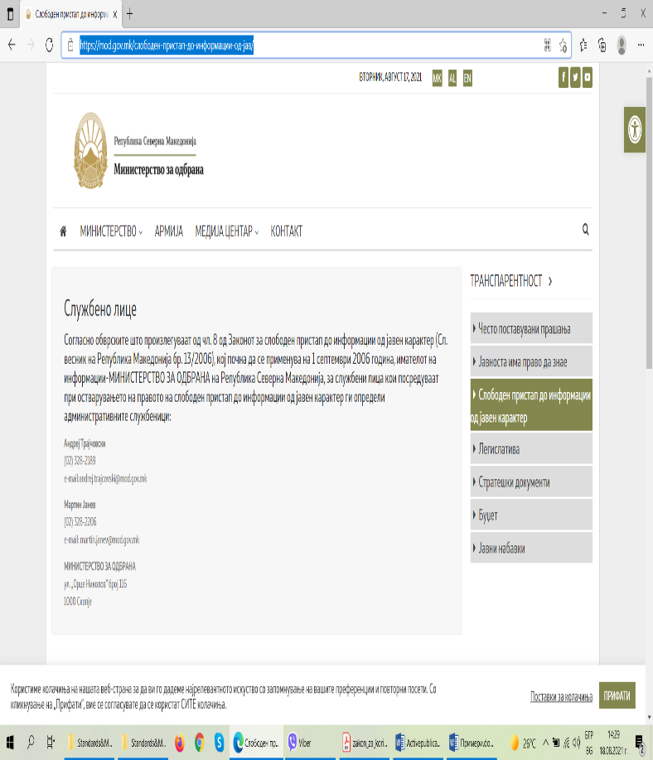

- Explanatory information for applicants – How to submit a request? (submission method – orally, in writing, and electronically), how to appeal the decision;

- Sample request for free access to information;

- Annual access to information report of the institution;

- Other information that would help citizens exercise their right to information –instructions, guidelines, etc.;

The second group of categories relates to institutional and organizational information about the information holder

- Information about the address, headquarters, competences, and webpage of the institution;

- Contact details of the institution and its head, including professional biography – telephone number and e-mail address;

- Organigram showing the internal organization of the information holders;

- List of all officials working in the institution, along with their designations and contact information – telephone number and e-mail address;

- List of all contractors of the institution – name, profession, term and purpose of the contract;

- Consolidated texts of the laws that establish the powers of the information holders;

- Internal acts of the institution adopted within the scope of its powers;

These are the administrative acts issued by the respective administrative body. For instance, these include all regulations, internal rules and instructions, as well as orders/decisions taken by the authority.

- Information regarding the types of services provided by the information holders;

- Other information related to the specific powers of the institution.

The third group of categories comprises operational information

- Strategies and strategic work plan of the institution;

- Annual work plans and programs with their annexes;

- Activity reports of the institution submitted to oversight authorities;

- Statistical data related to the life and health of citizens;

- Acts and measures issued within the competences of the institution;

- Fees related to the issuing of acts;

- Agendas and minutes of discussions of the collective bodies.

The fourth group of categories includes budgeting, financial information, and integrity

- Annual budget of the information holder;

- Annual financial report;

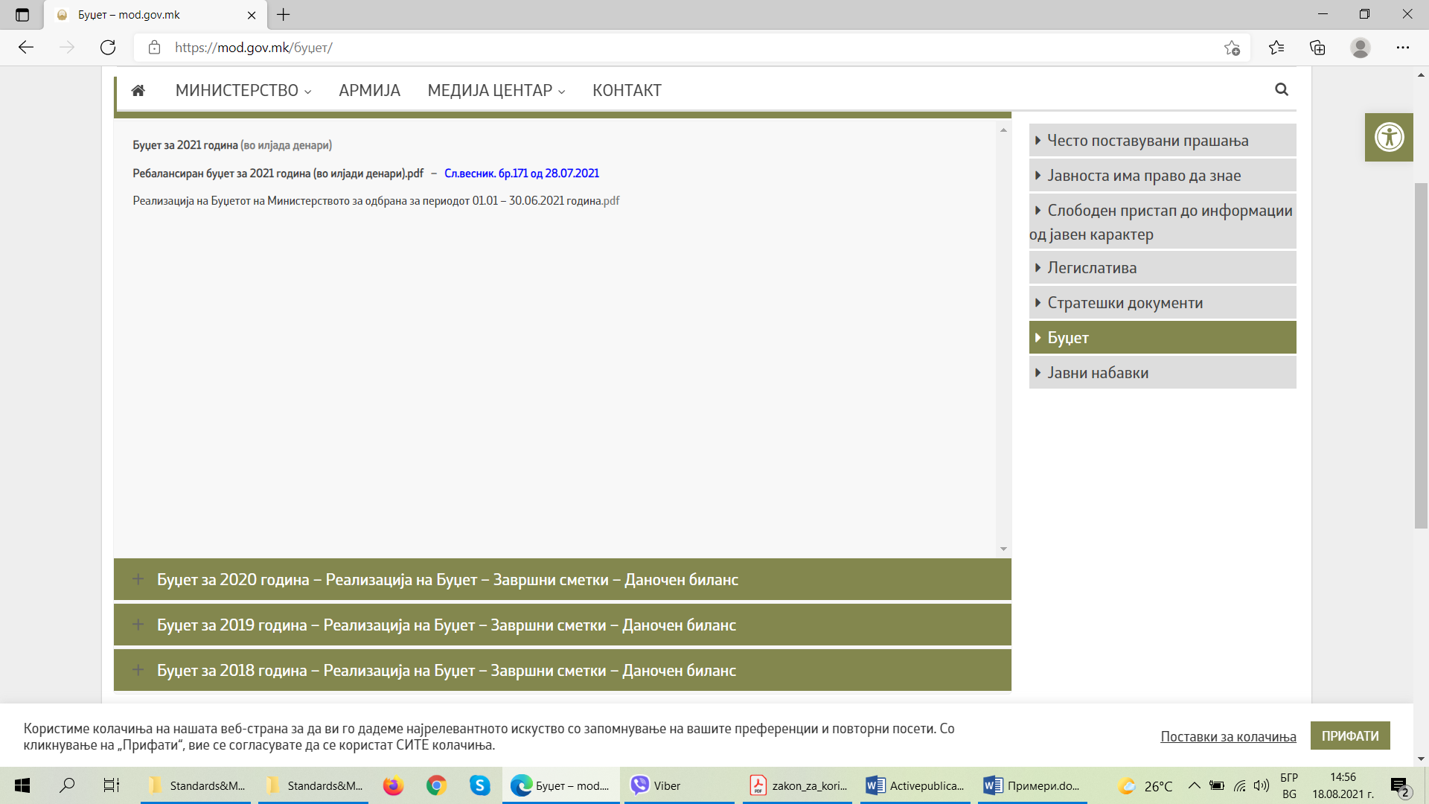
Буџет – mod.gov.mk

- Quarterly financial reports, if required from the institution;

- Inspection and audit reports;
- Annual public procurement plan;

- Public procurement notices;
- Concluded public procurement contract;

- Concluded concession contracts, if applicable;

- Public-private partnership contracts, if applicable.

Other information determined by law

If other legislation stipulates obligations to publish additional categories of information, the latter should be included in the mandatory publication list, which should be updated regularly. The information holders have a responsibility to review the list of categories of information subject to publication. The specified list should also be shown on the link where the information is published.

Publication of information in an open format
In accordance with the Law on the Re-use of Public Sector Information, every public sector organization must annually adopt a plan for gradual publication on the Internet, in an open data format, of all the free-access databases and resources it maintains.

The list of information holders is maintained by the Agency for the Protection of Free Access to Public Information. See: https://aspi.mk/ According to the Agency’s annual report for 2020, the number of information holder subjects is 1440. https://aspi.mk/%d0%b4%d0%be%d0%ba%d1%83%d0%bc%d0%b5%d0%bd%d1%82%d0%b8/%d0%b3%d0%be%d0%b4%d0%b8%d1%88%d0%bd%d0%b8-%d0%b8%d0%b7%d0%b2%d0%b5%d1%88%d1%82%d0%b0%d0%b8/
Official Gazette of the RNM, Issue 27 of 5 February 2014

